Screening for resistance to Xanthomonas vasicola pv. musacearum (Xvm)
R. Kanaabi, G. Mwanje and G. V. Nakato*
September 2021

International Institute of Tropical Agriculture (IITA) Uganda office; Plot 15B, East Naguru road; P.O. Box 7878; Kampala, Uganda
*Correspondence: V.Nakato@cgiar.org

Introduction
Xanthomonas vasicola pv. musacearum (Xvm) previously known as Xanthomonas campestris pv. musacearum (Studholme et al., 2020) is a plant pathogen that causes banana wilt also known as banana Xanthomonas wilt (BXW). Among banana diseases, Xanthomonas wilt, is reported to be the most devastating disease in East and Central Africa causing 100% yield loss, since it kills the entire plant and prevents fruit formation (Nakato et al., 2018).
Xanthomonas wilt, is commonly transmitted by contaminated garden tools, infected planting materials, and vectors like insects, birds, and browsing animals, (Nakato et al., 2014). Xvm survives on plant residues for 3 months (Nakato et al., 2018) hence it can be effectively controlled by uprooting, chopping, removing, and burying diseased stems, sterilizing and using clean garden tools as well as removing male buds early enough using a fork stick, which will prevent and control cross transmission to other non-infected plants, (Nakato et al., 2014).
The infection results into wilting and yellowing of youngest leaves or the male buds, premature ripening of fruits, which results from internal vascular bundle discoloration mainly in the pseudo stem producing a yellow discharge “ooze”, (Biruma et al., 2007).
Among banana cultivars however, a wild form Musa Balbsiana has proved resistant to this infection, genetic studies are conducted to determine the source of resistance, which resistance genes can be transferred to other genotypes through conventional breeding, and genetic engineering (Sekiwoko et al., 2006)

Besides Musa Bulbsiana`s resistance to Xvm, it belongs to BB genome subgroup hence not preferred for breeding since the available edible bananas belong to AA genome subgroup, however with molecular characterization, present studies reveal the presence of resistant genes in A genomes banana subgroups especially Musa acuminata, which can be effectively used in breeding of edible bananas and plantain, (Nakato et al., 2019).
This screening protocol is developed to provide guidance for the Banana breeding program to determine resistance of banana genotypes to Xanthomonas vasicola pv. musacearum (Xvm) which causes Xanthomonas wilt of banana.

Materials and methods
Plant materials
TC generated plant material including:
- Test genotypes (Parental genotypes and newly developed hybrids)
- Tolerant check
  - Monyet
- Land race controls:
  - TM-28 OBINO LEWAI
  - Mbwazirume
  - Mchare

Other materials (For screenhouse evaluations)
- Sterile forest soil
- Sterile sand
- 13-liter plastic pots
- Watering cans
- Xvm inoculum
Experimental design
The experiment will be potted and established in an open space with no environmental control but minimal management practices like watering during dry spells.
Parental genotypes
Partially replicated experimental design (P-Rep) with three blocks will be adopted with each parental genotype occurring in duplicate and the checks in triplicate for the entire experimental set up. Each plot will constitute three plants per genotype. P-rep designs are useful when plant materials and space are limiting factors. In-fact, P-rep designs allow for repeated trial evaluations at different locations. The experimental design for the available 51 parental genotypes including checks is shown in Figure 1 below. The average efficiency 0.99 indicating that the design is optimal.
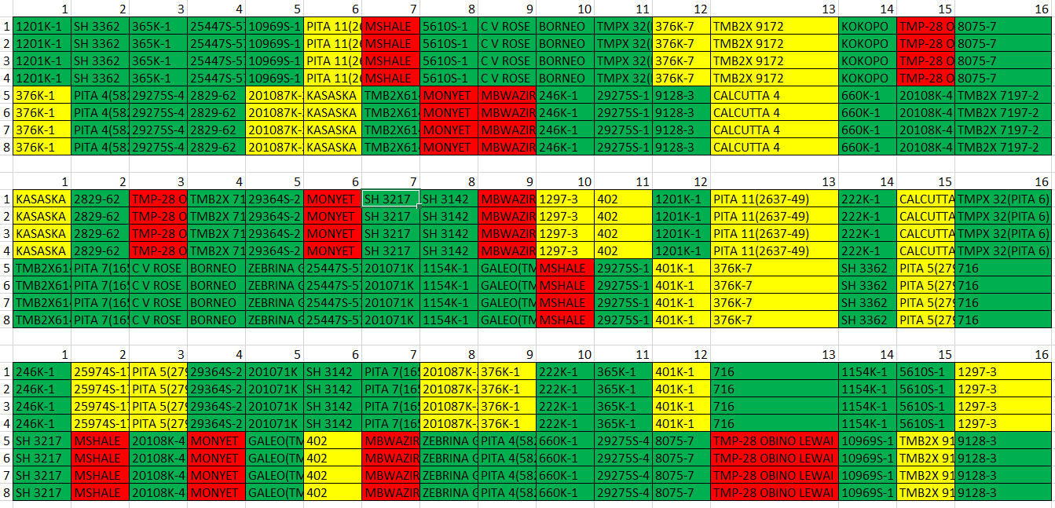
Figure 1.P-rep lay out for banana Xanthomonas wilt screening for the available 51 parental lines including checks
Hybrids
The augmented design resulting into an incomplete block design where standard checks are replicated in each block and test genotypes will be adopted for the hybrids. Such augmented designs are very useful where very large numbers of hybrids are produced with limited planting materials and reduced space.

Methodology
Generation of plants
The genotypes to be screened are generated from Tissue culture (TC), grown in the nursery to harden for 8 weeks under controlled environmental conditions (humid chamber and the screen house) and later transferred to planting bags containing a sterilized mixture of garden soil, Manure and sawdust mixed in a ratio of 3:1:1 respectively from where they are left to fully grow for 3 months.
Xvm inoculum preparation
Total volume of inoculum to be prepared is dependent on the number of genotypes to be inoculated.
- Xvm cultures are aseptically introduced in YPG broth and incubated at 25ºC - 28ºC for 48hours with shaking, to optimize cell growth.
- Record the culture cell concentration (Absorbance/Optical Density) is using a spectrophotometer with a light wavelength of 600 (O.D₆₀₀).
- Adjust the culture cell concentration to desired concentration of 10⁸ Colony Forming Units (CFU) per ml which is approximately 0.5 OD₆₀₀ using C₁V₁ = C₂V₂
Plant inoculation (Nakato et al., 2018)
- 1ml of the 10⁸ CFU/ml cell concentration is introduced into the youngest open leaf via the petiole/midrib, for all test genotype.
- Negative controls are inoculated using sterile distilled water.
- Record date on which inoculation has been completed.
- Observe plants weekly for disease symptom development for 4 months.
Data collection and Analysis (Nakato et al., 2019)
- Data is collected on a weekly basis, proceeding the date of inoculation for a period of 15 weeks.
- Parameters recorded include:
- Number of functional leaves
- Number of chlorotic leaves (leaf wilting)
- Death of entire plant (if any) per genotype are recorded
NB: Every new observed Chlorotic leaf is tagged with a tape to eliminate errors due to counting other chlorotic leaves caused by normal leaf synesis, (If possible other chlorotic leaves should be eliminated by cutting them off)

Disease incubation, days to symptom development per genotype can be extracted from the weekly data records. Disease Index (DI), Days of Post inoculation (DPI) and Area Under Disease Progression Curve (AUDPC) are computed using the formulae below:

Disease Index (DI)
=(((1*A) + (2*B) + (3*C))/Number of Plants) x100

Where
A = Number of plants with inoculated leaf showing symptoms
B = Number of plants with uninoculated leaves showing symptoms
C = Number of wilted Plants

Days of Post Inoculation (DPI)
= Time interval (Counting number of Days from inoculation to symptom development and complete wilting).

Table 1: Disease classification based on DI
Disease Classification
Resistant(R) | No plants wilted
Tolerant (T) | <30% of plants wilted
Moderately Susceptible (MS) | >30% and <50% of plants wilted
Highly Susceptible(HS) | >50% of plants wilted

Area Under Disease Progression Curve (AUDPC):
$$f\left(AUDPC\right)=\sum_{i=1}^{N_{i}−1}{\left(\frac{Y_{i}+Y_{i+1}}{2}\right)}\left(t_{i+1}+t_{i}\right)$$

Where:
t = time in weeks of each Reading
Y = Percentage of affected plants at each Reading
N = Number of Readings
i = Reading

Appendix
    - Isolation of Xvm
Xvm isolation media (Mwangi et al., 2007)
- Wilbrink media
- YPGA (5g/l Yeast, 5g/l Peptone, 10g/l Glucose and 15g/l Agar)
- YDCA (10g/l Yeast, 20g/l CaCO₃ 20g/l Dextrose and 15g/l Agar)
- Cellobiose-cepholexin Agar (CCA)
Materials
- Well labeled Plant Samples (preferably pseudo stem)
- Laminar flow hood
- Toothpicks
- Cling Film
- Wilbrink Isolation media plates or YPGA media plates (Yeast 5g/l, Peptone 5g/l, Glucose 10g/l and Bacteriological Agar 15g/l)
- Sterile Toothpicks
- 5-fluorouracil for eliminating fluorescent Pseudomonads (Nakato V et al., 2018)
- Cycloheximide for Fungal growth inhibition

- Media is sterilized by autoclaving at 121 Ibs pressure for 15 minutes and dispensed 20mls poured into petri dishes after cooling to 30ºC.
- The sample initials are recorded in the Laboratory sample book.
- Using a sterile knife, the two outer most sheaths are peeled off and discarded from the 30-cm portion of the pseudo-stem.
- The remaining exposed outer surface is sterilized with 70% ethanol in a laminar flow hood and placed on absorbent tissue paper to dry.
- Aseptically cut the sterilized stems into two cross-section portions and keep slightly slanting for 15-10 minutes until Bacterial Ooze is discharged.
- The Ooze is picked using a sterile toothpick, and directly streaked on the media plate (Wilbrink or YPGA).
- The plate is sealed using a cling film (to prevent contamination) and incubated at 25ºC for 3 days.
- Yellow mucoid convex shaped colonies are picked from media plate and re-cultured on YPGA media to obtain pure colonies.
- Confirmation can be done using Xvm specific markers (Nakato et al., 2019)
- Pure colonies are stored on 20% glycerol 50% YPG broth for long term storage at -80ºC
- Wilbrink media Preparation, (Wang et al., 2018)
Wilbrink Media: | 1000ml | 500ml | 200ml
Bacto Peptone | 5g | 2.5g | 1g
Sucrose | 10g | 5g | 2g
K2HPO4 | 0.5g | 0.25g | 0.1g
MgSO4·7H2O | 2.5g | 1.25g | 0.5g
Na2SO3 | 0.25g | 0.125g | 0.05g
Agar | 15g | 7.5g | 3g
YPGA Media:
Yeast | 5g | 2.5g | 1g
Peptone | 5g | 2.5g | 1g
Glucose | 10g | 5g | 2g
Agar | 15g | 7.5g | 3g
Table 2: Media for Xvm isolation

- Pictorial of Xvm symptoms
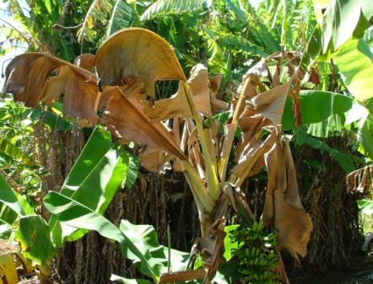  Image 1: Leaf Bxw Symptoms | 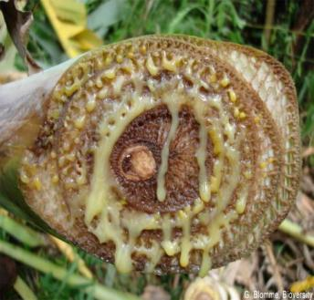  Image 2: Yellow discharge (Ooze) in Pseudostem
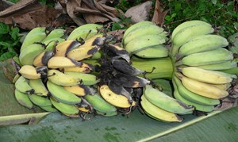  Image 3: uneven Ripening and rotting of fruits |  | 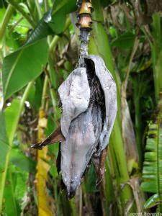  Image 4: Wilting of the male bud bracts

- Pure Xvm colonies on YPGA media
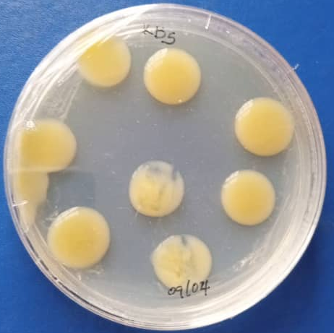  Image 5: KB5 Xvm culture on YPGA media plate | 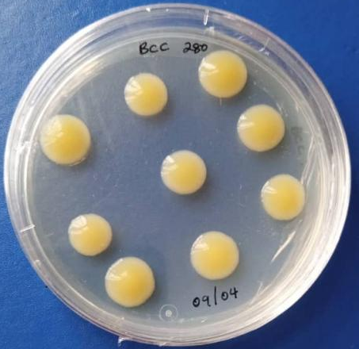  Image 6: Bcc 280 Xvm culture on YPGA media plate

References
Mahuku G. 2004. A simple extraction method suitable for PCR based analysis of plant, fungal, and bacterial DNA. Plant Molecular Biology Reporter, 22: 71-81.

Wang H, McTavish C, Turechek WW. 2018. Colonization and Movement of Xanthomonas fragariae in Strawberry Tissues. Phytopathology, 108 (6): 681- 690.
Adriko J, Aritua V, Mortensen CN, Tushemereirwe WK, Kubiriba J, Lund OS. 2012. Multiplex PCR for specific and robust detection of Xanthomonas campestris pv. musacearum in pure culture and infected plant material. Plant Pathology 61, 489-497.

John JA, Williams ER. 1995. Cyclic and Computer-Generated Designs. Second Edition. Chapman and Hall, London. 255 p.

Lewis LMI, Tusiime G, Miller SA. 2010. A Polymerase Chain Reaction Assay for the Detection of Xanthomonas campestris pv. musacearum in Banana. Plant Disease, 94:109-114.

Mwangi M, Mwebaze M, Bandyopadhyay R et al., 2007. Development of a semiselective medium for isolating Xanthomonas campestris pv. musacearum from insect vectors, infected plant material and soil. Plant Pathology, 15: 383– 90.

Nakato V, Mahuku G, Coutinho T. 2018. Xanthomonas campestris pv. musacearum: a major constraint to banana, plantain and enset production in central and east Africa over the past decade. Molecular Plant Pathology, 19: 525–36.

Nakato GV, Christelov P, Were E, Nyine M, Coutinho TA, Dolezel J, et al. 2019. Sources of resistance in Musa to Xanthomonas campestris pv. musacearum, the causal agent of banana Xanthomonas wilt. Plant Pathology 68, 49–59.
Ssekiwoko F, Tushemereirwe WK, Batte M, Ragama PE, Kumakech A. 2006. Reaction of banana germplasm to inoculation with Xanthomonas campestris pv. musacearum. African Crop Science Journal 14, 151– 5.
Studholme DJ, Wicker E, Abrare SM, Aspin A, Bogdanove A, Broders K, Dubrow Z, Grant M, Jones JB, Karamura G, Lang J, Leach J, Mahuku G, Nakato GV, Coutinho T, Smith J, Bull CT. 2020. Transfer of Xanthomonas campestris pv. arecae and X. campestris pv. musacearum to X. vasicola (Vauterin) as X. vasicola pv. arecae comb. nov. and X. vasicola pv. musacearum comb. nov. and Description of X. vasicola pv. vasculorum pv. nov. Phytopathology, 110 (6): 1153-1160.

