
Banana Diseases and Pests
Field Guide for Diagnostics and Data Collection

Improvement of banana for smallholder farmers in the Great Lakes Region of Africa

A. Viljoen, G. Mahuku, C. Massawe, R.T. Ssali, J. Kimunye,
G. Mostert, P. Ndayihanzamaso and D.L. Coyne

Improvement of banana for smallholder farmers in the Great Lakes Region of Africa
This unique project seeks to improve the productivity of banana in Tanzania and Uganda through the development of hybrids that are expected to have 30% higher yield compared to varieties currently grown by farmers under the same conditions. In particular, the project will strengthen banana breeding programmes by developing new and high-yielding disease- and pest-resistant hybrids of the two most popular cooking bananas in the region: East African highland banana (EAHB), also known as Matooke, and Mchare bananas.

IITA Ibadan, Nigeria
PMB 5320, Oyo Road
Ibadan, Oyo State
Telephone: (234-2) 7517472
Fax: +44 208 7113786
E-mail: iita@cgiar.org
Web: www.iita.org
ISBN: 978-978-8444-80-0
© 2017 International Institute of Tropical Agriculture

All rights reserved. The publisher encourages fair use of this material provided proper citation is made. No reproduction, copy or transmission of this report may be made without written permission of the publisher.
Front cover photo: Privat Ndayihanzamaso

Correct citation:
Viljoen, A., Mahuku, G., Massawe, C., Ssali, R.T., Kimunye, J., Mostert, G., Ndayihanzamaso, P. and Coyne, D.L. 2017. Banana Diseases and Pests: Field Guide for Diagnostics and Data Collection. International Institute of Tropical Agriculture (IITA), Ibadan, Nigeria.



Contents

Abbreviations 5
Author information 6
Introduction 8
References ………………………..………………………………………………….……………….9
Banana Fusarium wilt 10
Background 10
Symptoms 11
Sample collection 15
Pathogen isolation 17
Pathogen identification 19
Field and greenhouse trials 20
Scoring of Fusarium wilt trials 24
References and useful reading 29

Yellow and Black Sigatoka 31
Background 31
Symptoms 32
Disease cycle and epidemiology 35
Sample collection 36
Pathogen isolation 37
Pathogen identification 43
Field and greenhouse trials 45
Scoring of Sigatoka trials 47
References and useful reading 50

The banana weevil 53
Background 53
Symptoms 53
Sample collection 54
Banana weevil identification 56
Field and greenhouse efficacy and screening trials 56
Scoring of banana weevil trials 57
References and useful reading 59

Banana nematodes 60
Background 60
Symptoms 60
Disease cycle and epidemiology 63
Sample collection 64
Nematode isolation 64
Nematode identification 68
Scoring of nematode trials 71
References and useful reading 73

Abbreviations

CLA carnation leaf agar
CM chlorate medium
CTAB cetyl-trimethyl ammonium bromide
DEB DNA extraction buffer
EDTA ethylenediaminetetra-acetate
Foc Fusarium oxysporum f. sp. cubense
PCR polymerase chain reaction
PDA potato dextrose agar
PDB potato dextrose broth
PVP polyvinyl pyrrolidone
RCBD randomised complete block design
RDI rhizome discolouration index
SI (disease) severity index
VCG vegetative compatible groups
WA water agar
YLS youngest leaf spotted

Author information

This field guide on four important pests and diseases of banana was produced within the framework of the project on ‘Improvement of banana for smallholder farmers in the Great Lakes Region of Africa’. The authors of the guide are scientists from four of the partners in the project: Stellenbosch University (SU), the International Institute of Tropical Agriculture (IITA), the National Agricultural Research Organisation (NARO) in Uganda, and the Horticultural Research Institute (ARI) in Tanzania.

Stellenbosch University (SU) is amongst South Africa's leading tertiary institutions based on research output, student pass rates and rated scientists, and is recognised internationally as an academic institution of excellence. The university is home to an academic community of 29 000 students (including 4 000 foreign students from 100 countries) as well as 3 000 permanent staff members (including 1 000 academics) on five campuses. As research partner, SU participates in various international academic networks. The scenic beauty of the Stellenbosch area; state-of-the-art, environmentally friendly facilities and technologies; and the visionary thinking about the creation of a sustainable 21st-century institution, makes for the unique character of Stellenbosch University.

International Institute of Tropical Agriculture (IITA) is an Africa-based international not-for-profit research-for-development organization, established in 1967, and governed by a board of trustees. IITA is a member of the CGIAR Consortium, a global research partnership for a food secure future. IITA’s mission is to offer a leading research partnership that facilitates agricultural solutions for hunger, poverty, and natural resource degradation throughout the tropics. IITA has over 100 internationally recruited staff and around 1 000 support staff based in various IITA stations across Africa. IITA’s mission is in line with that of the new CGIAR and focuses on the four system-level outcomes (SLOs): (1) increase in food security, (2) reduction of rural poverty, (3) reduction of undernutrition, and (4) more sustainable management of natural resources.

National Agricultural Research Organization (NARO) is the apex body for guidance and coordination of all agricultural research activities in the national agricultural research system in Uganda. NARO is a Public Institution established by an act of Parliament, which was enacted on 21st November 2005. NARO comprises of 15 semi-autonomous public agricultural research institutes across the various agro-ecological zones of Uganda. The research capacity and reputation of the Public Agricultural Research institutes has been built over several decades since 1898. For instance, banana research has been conducted for over 25 years at NARO, generating and delivering evidence-based technologies, management practices and policy options for improved nutrition, resilience and productivity in East and Central Africa. NARO has, over time, built capacity (infrastructural and human), and a dependable and formidable regional and international network of partners for delivering research and scaling outputs to the banana farming and trading communities.

Horticultural Research and Training Institute (ARI-HORTI), Tengeru was established during 1980 with the national mandate to undertake horticultural research and training activities. Its main objective is supporting horticultural activities connected with training, research and extension on vegetable seed production and plant propagation. Research work at HORTI Tengeru is currently being conducted on vegetables (exotic and indigenous), fruits (exotic and indigenous), bananas, root and tuber crops, mushrooms (oyster mushroom) and spices. This research is supported by units responsible for liaision and dissemination of technologies to clients, with 40 resource personnel manning the institute. Among the current activities being carried out are the collection and conservation of local banana germplasm, expansion of the varietal choices and gene base of banana growers by exchanging and introducing selected superior banana varieties with enhanced pest and disease resistance and high yield potential from reputable breeding programs from across the world, strengthening the capacity (institutional and human) for the transfer and application of improved banana production strategies by establishing links with partners (public and private), dissemination of improved husbandry practices, popularization of the use of clean planting materials, and the management of pests and diseases (nematodes, weevils and soil fertility improvement, Fusarium wilt).

Acknowledgement
This authors of this field guide would like to acknowledge the efforts of Ms Lizeth Swart (SU) for technical editing of the text, and Sun Media for printing of the guide.
Introduction

Banana is a staple food in East and Central Africa (ECA), where it provides approximately 20% of the total calorie consumed per capita. Uganda and Tanzania are two of the main producers of bananas in the region, mainly through the cultivation of two unique cooking types, the East African highland (EAHB or Matooke) and Mchare bananas. Production of bananas in ECA, however, has declined since the 1970s, and now yields a fraction of its potential (Van Asten et al., 2005). While low yields are partly due to poor soil fertility in the region (World Bank, 2010), pests and diseases have played a significant role in reducing banana production (Swennen et al., 2013).
The project Improvement of banana for smallholder farmers in the Great Lakes Region of Africa focuses on producing high-yielding banana hybrids by developing host plant resistance to diseases and pests important to the region. These diseases and pests include Fusarium oxysporum f. sp. cubense (Foc), which causes Fusarium wilt, banana weevils and nematodes, and Mycosphaerella spp., which cause Sigatoka leaf spots (Edmeades et al., 2007; Swennen et al., 2013). Diseases and pests pose a substantial problem to sustainable banana production in ECA, with a significant risk to destabilize food security and household income in this region.
Breeding for host plant resistance is the most appropriate strategy for managing diseases and pests, as pesticides are often not accessible by farmers in ECA, not available, environmentally unattractive or simply not an alternative (as is the case for Fusarium wilt). Laudable progress has been made in breeding and selection for combined resistance to Foc and nematodes (Rowe and Rosales, 2000), even though they do not meet the cooking-banana end-user preference for flavour, taste and texture. The National Agricultural Research Organization (NARO) of Uganda, in collaboration with the International Institute of Tropical Agriculture (IITA), however, have jointly developed 27 EAHB (NARITA) improved hybrids with various preferential traits. Two of these hybrids were released as cultivars in 2010. At least 20 of the NARITA hybrids will be tested in this project for agronomic performance, disease and pest resistance, and fruit quality in various geographic locations, with the objective to identify hybrids with at least 30% higher yield and that are 50% more resistant to at least three target disease and pest constraints.
Breeding for resistance in banana is complicated by a number of constraints, including pathogen and pest diversity. Hence, screening against the different key races and species is essential. Field screening also complicates the evaluation process as it is time-consuming, expensive and often subjected to uneven natural infection levels. Standardised protocols are consequently necessary to rapidly, consistently and accurately test banana breeding lines and hybrids for resistance to pathogens and pests under controlled conditions. In addition, molecular technologies to support pathogen identification and resistance screening are required.
The Field Guide for Disease Diagnostics and Data Collection of banana pests and diseases has been prepared to assist banana scientists, technical staff and extension officers to collect pathogens and pests from testing and breeding sites in Uganda and Tanzania. These will then be sent for identification and characterization to Stellenbosch University (SU), IITA, NARO and Horticultural Research and Training Institute (ARI-HORTI) in Tengeru. This is to ensure that field evaluation of hybrids and banana breeding efforts are performed against all variants of banana pathogens and pests in ECA. Methods to evaluate NARITA hybrids and other breeding materials for resistance to the target pathogens and pests are also presented. To accelerate the breeding process, early plant screening methods are proposed for Fusarium wilt, Mycosphaerella spp., weevils and nematodes.

References
Edmeades, S., Nkuba, J.M. and Smale, M. 2007. Use of hybrid cultivars in Kagera region, Tanzania, and their impact. In: Smale M. and Tushemereirwe, W. K. (eds). An economic assessment of banana genetic improvement and innovation in the Lake Victoria Region of Uganda and Tanzania. Research Report No. 155. International Institute of Tropical Agriculture, Washington, D.C.
Rowe, P.R. and Rosales, F.E. 2000. Conventional banana breeding in Honduras. Pages 143-172 in: Diseases of Banana, Abaca and Enset (Ed. D.R. Jones). CABI Publishing, New York, USA.
Swennen, R., Blomme, G., VanAsten, P., Lepoint, P., Karamura, E., Njukwe, E., Tinzaara, W., Viljoen, A., Karangwa, P., Coyne, D. and Lorenzen, J. 2013. Pages 85-104 in: Agro-ecological intensification of farming systems in the East and Central African Highlands (Eds: B. Vanlauwe, P. van Asten and G. Blomme). Routledge Publishers, Oxon, UK and New York, USA. ISBN: 978041553273-0.
Van Asten, P.J.A., Gold, C.S., Wendt, J., De Waele, D., Okech, S.H.O., Ssali, H. and Tushemereirwe, W.K. 2005. The contribution of soil quality to yield and its relation with other banana yield loss factors in Uganda. Pages 100–115 in: Proceedings of a workshop held on farmer participatory testing of IPM options for sustainable banana production in Eastern Africa. (Eds. G. Blomme, D.S. Gold and E. Karamura, E.). Seeta, Uganda, 8–9 December 2003. International Plant Genetic Resources Institute, Montpellier, pp.
World Bank, Food and Agriculture Organization, and International Fund for Agricultural Development. 2009. Gender in Agriculture: Sourcebook. Washington, D.C.: World Bank Publications.

Banana Fusarium Wilt

Background

Fusarium wilt, caused by Fusarium oxysporum f. sp. cubense (Foc), is a destructive soil-borne disease of bananas present in all banana-producing countries in sub-Saharan Africa. The disease was first discovered in Australia in 1876 but it became prominent when it almost destroyed the international banana export industry, based on Gros Michel bananas, in the 1900’s (Stover, 1962). Due to the ability of Foc to survive in infested soils for decades, Fusarium wilt is extremely difficult to manage. The disease in Central America was brought under control when Gros Michel bananas were replaced with Cavendish cultivars; a banana variety which is not affected by the strain present in Central America (Foc race 1) (Stove, 1962). Cooking bananas and plantains grown in Africa are also able to resist Foc race 1. Since the 1990s, Cavendish bananas in tropical Asia became severely affected by a new strain, known as Foc Tropical Race 4 (TR4). The ability of African bananas to withstand and resist Foc TR4 is largely unknown.
Foc consists of three races and 24 vegetative compatibility groups (VCGs). Nine VCGs of Foc are present in Africa (Blomme et al., 2013), of which VCGs 0124 and 0125 are the most widely distributed in East and Central Africa (ECA) (Karangwa, 2015). Foc has been introduced into new growing areas through the movement of infected planting materials (Stover, 1962). Their occurrence in Africa is strongly related to the distribution of susceptible banana cultivars (Blomme et al., 2013). The disease is thus mostly observed in areas where susceptible dessert bananas are grown, but not in fields planted to the East African highland (Matooke) cooking bananas. In Africa, Foc TR4 was introduced into northern Mozambique in 2013 (Viljoen, unpublished data). This strain is expected to spread across ECA, where it may affect both dessert and cooking bananas on the continent.
Admirable progress has been made in breeding banana hybrids resistant to Foc (Rowe and Rosales, 2000). Foc race 1-resistant hybrids developed by FHIA (a banana breeding program in Honduras), such as the FHIA-17 and FHIA-25, are appreciated in many parts of Africa (Karamura et al., 1998; Msogoya et al., 2006; Dzomeku et al., 2008; Gaidashova et al., 2008). They, however, often fail to meet the Matooke end-user preference for flavour, taste and texture. It is thus important that banana hybrids popular to African consumers be developed by introducing resistance from wild diploids into local, preferred varieties. To ensure that breeding efforts target all races and VCGs of Foc in ECA, rapid diagnostic methodologies need to be developed to accurately detect them. Reliable early screening methods also need to be developed to accelerate the banana breeding process.
Symptoms

Banana plants with Fusarium wilt can be identified by the conspicuous yellowing and wilting of older leaves which progress to the youngest leaves until affected plants are eventually killed (Fig. 1A). The disease should not, however, be identified only from these external symptoms, as several other biotic (bacterial wilt, Armillaria, banana weevil) and abiotic stresses (nutrient deficiency, water-logging) of banana can result in the yellowing and wilting of banana plants. For this reason, Fusarium wilt in suspect plants needs to be identified by also inspecting internal symptoms in the pseudostem and rhizome, and by isolating Foc from affected tissue.

External symptoms
The most characteristic symptom of banana Fusarium wilt is chlorosis (yellowing) of older banana leaves. The yellowing most often begins at the leaf margins, from where it progresses to the leaf midriff (Fig. 1B). In some banana varieties, such as Cavendish bananas affected by Foc TR4, the chlorosis is followed by necrosis (browning caused by death of leaf tissue). In others, such as Pisang Awak, the browning of affected leaves is seldom observed. In Gros Michel affected by Foc race 1, yellowing may not be obvious on leaves (Fig. 2). Irrespective of the variety involved, however, two indicators are always associated with leaves affected by Fusarium wilt: the symptoms progress upwards from the older to the younger leaves, and the petioles of affected leaves buckle and hang down the pseudostem.
A second external symptom often linked to banana Fusarium wilt is the splitting of the pseudostem (Fig. 1C). The splitting is caused by the inability of dead leaf bases to expand as the plant grows, thus splitting open as the inner pseudostem swells. Pseudostem splitting is not always associated with Fusarium wilt though, and there may be other reasons for the splitting of pseudostems. This symptom, therefore, needs to be considered along with leaf yellowing and wilting in suspect plants.

Internal symptoms
Fusarium wilt results in very characteristic internal symptoms in the rhizome and pseudostem, irrespective of the affected variety. When sliced longitudinally, affected pseudostems present reddish- to dark-brown lesions inside the leaf bases that form the pseudostem (Fig. 1D). The bunch stalk, however, will be clean of such symptoms. It is always advisable to split the pseudostems longitudinally through the discoloured lesions, as their progression through the vascular tissue then becomes very clear. Early infection in banana pseudostems are often yellow to dark red, and limited to the xylem vessels. This is the best material to collect for the isolation of Foc. The older the infection becomes, the more expanded and darker the lesions will become, and such lesions can be co-colonised by secondary contaminants. Despite the age of the lesion, it is important to confirm that they are continuous, which separates internal symptoms caused by Foc from those caused by other biotic stresses.
When external symptoms are visible on banana plants, but internal symptoms are absent from the pseudostem, it becomes important to inspect the rhizome. The plant should be cut open at soil level to expose the pseudostem base, and then pushed over. Diseased plants will have a very characteristic yellow to dark-brown discolouration of the inner rhizome, which usually starts at the edges and progresses inwards (Fig. 1E). Very often only part of the inner rhizome is affected, but with progression of the disease the entire inner rhizome becomes affected. The outer rhizome is never affected. The part of the rhizome that had been pushed over (not cut) will display yellow strands of the rhizome which are attached to both the top and bottom halves of the rhizome. When no discolouration is observed within the rhizome, the external symptoms are caused by something other than Foc. In such cases, the inner rhizome might display black spots instead of the continuous yellow to reddish-brown discolouration associated with Fusarium wilt.

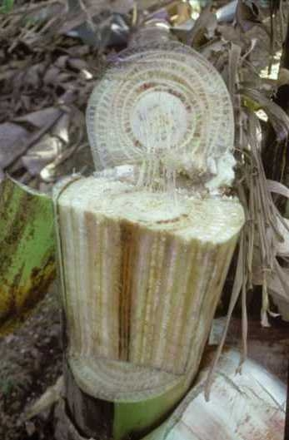
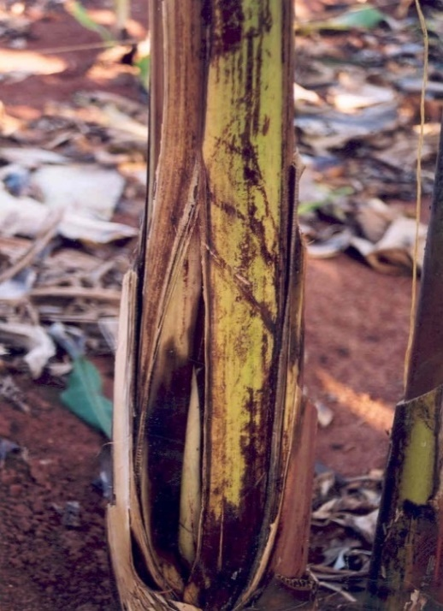
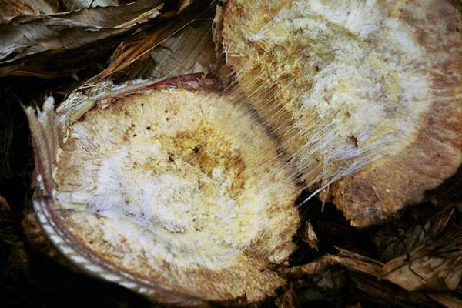
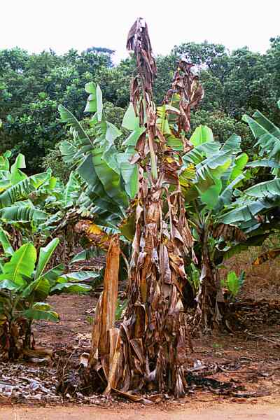
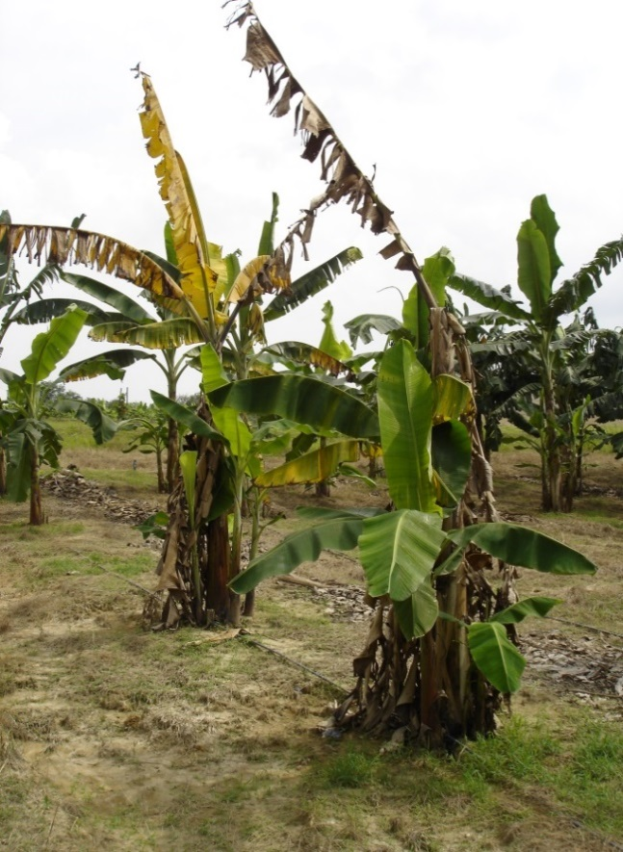
A
D
C
B
E

Figure 1. Disease symptoms of Fusarium wilt of banana caused by Fusarium oxysporum f. sp. cubense. Affected plants wilt rapidly, older and then younger leaves become yellow and brown, and plants eventually die (A, B). In some cases, the pseudostem base splits (C). Internally, the vascular bundles in the pseudostem turn yellow to reddish-brown (D), while a deep golden discolouration of the inner rhizome develops (E).
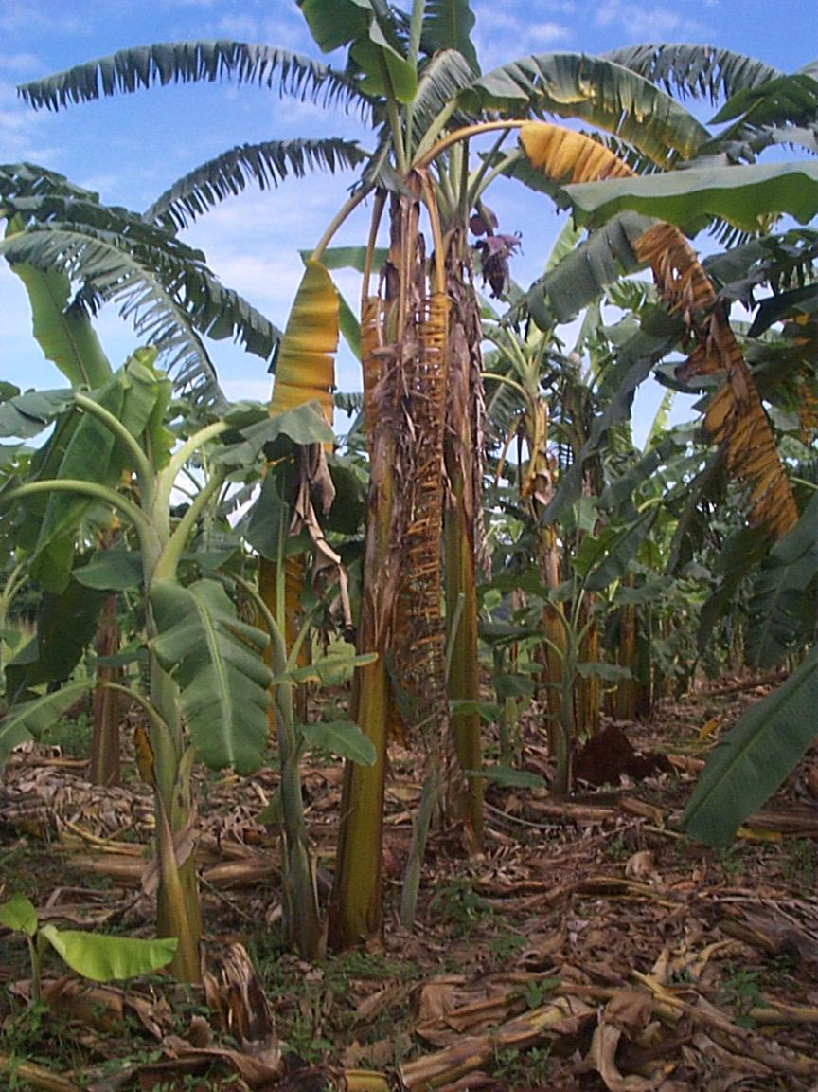
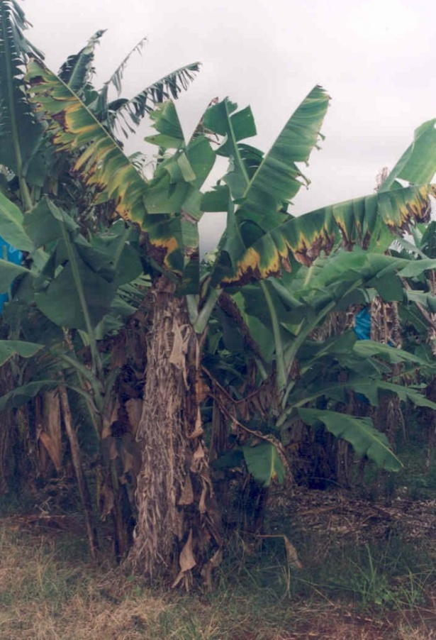
B
A

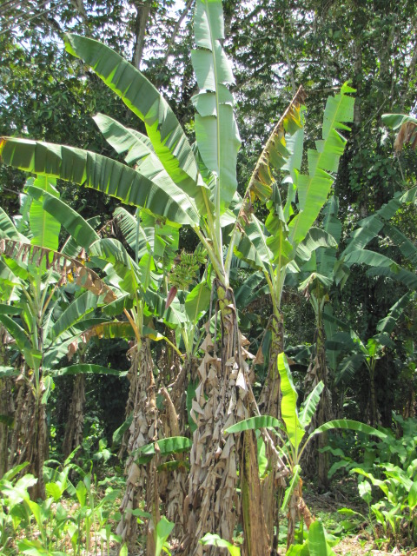
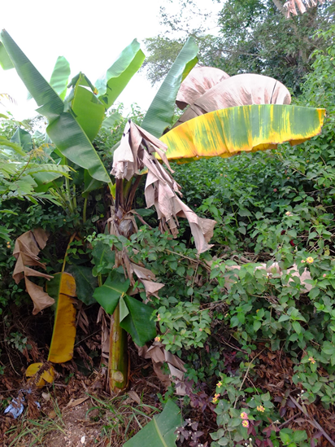
C
D
Figure 2. Disease symptoms of Fusarium wilt on different banana varieties: (A) Cavendish bananas in South Africa, (B) Pisang Awak in Uganda, (C) Pisang Awak in Mozambique, and (D) Gros Michel in Costa Rica.
Sample collection

Taking a sample from the diseased host plant
Samples for the identification of the cause of Fusarium wilt should be collected from the pseudostem of banana plants with Fusarium wilt symptoms. Two types of collection can be done: destructive and non-destructive sampling. For destructive sampling, the pseudostem is cut down and split longitudinally. Samples should then be taken where continuous discoloured vascular strands are evident (Fig. 3). Non-destructive sampling involves the slicing open of a pseudostem up to 3 cm deep, the cutting out of a block of tissue, or the removal of pseudostem tissue using a cork borer. Once sampling is completed, the wound must be closed by attaching the tissue from which samples were collected, back onto the pseudostem with masking tape. Samples should be taken from as low in the pseudostem as possible, but not from areas where decay is advanced. Also, the sample should be taken from as close to the centre of the pseudostem as possible, as opposed to the outermost leaf bases.
After collection, samples must be covered with sterile paper towel and kept in paper envelopes or bags until the strands can be excised. The use of plastic bags should be avoided, as banana tissue is very wet, which could increase the risk of bacterial contamination of samples. The samples should then be stored in a cool, dry container, as warm weather could rapidly result in the deterioration of collected material. Once samples are contaminated with bacteria and secondary invading fungi, it becomes extremely difficult to recover pure cultures of Foc. Keeping collected strands dry, thus, is of great importance. Photos should be taken of diseased plants and the samples collected, if possible. Envelopes should be marked with:
- Sample number (one sample number per plant).
- Date.
- The variety of the host plant, including local names (and uses if known).
- Age of plant/plantation.
- Site of sampled plants (garden, commercial plantation, village or the wild).
- Extent of the diseased area where the plant was collected, with photos.
- Location, with GPS coordinates.
- Collector’s names.
- Other useful observations, such as the source of the planting material, soil conditions (water-logging, soil type etc.), other varieties grown in the vicinity, etc.

Note: When collecting samples, it is best to take samples from banana plants in established plantations, rather than recently planted and young plants. Always include a phytosanitary certificate/importation permit when shipping the samples internationally.
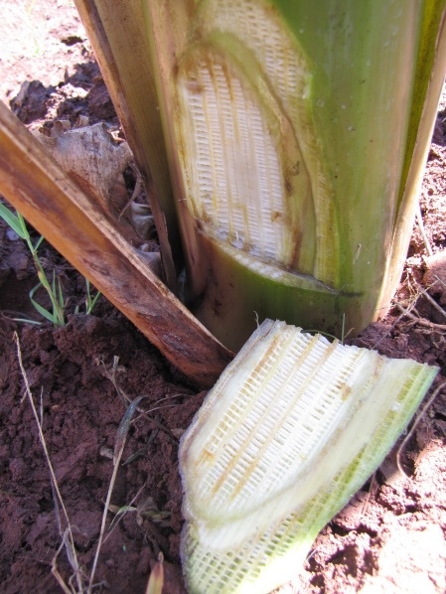
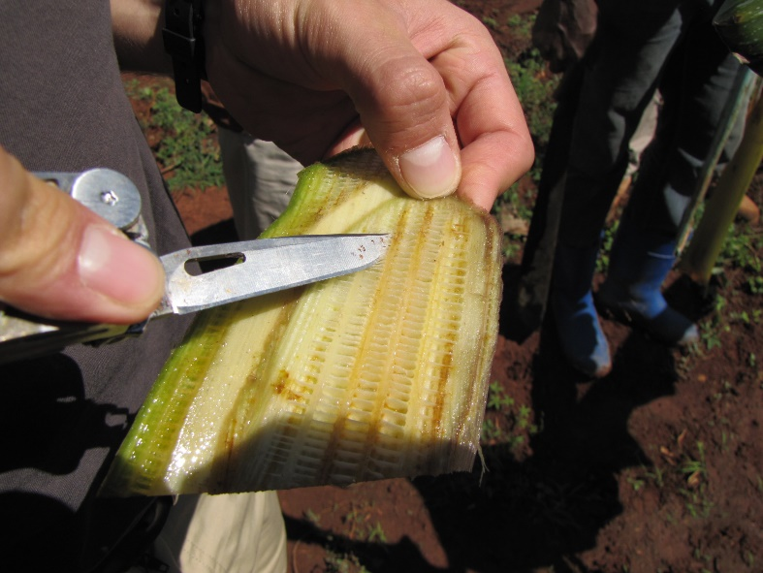
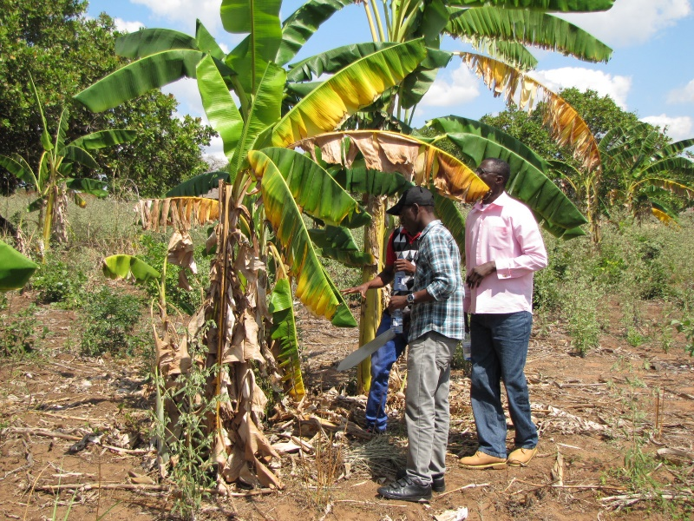
A
B
C

Figure 3. Collect vascular strands from banana pseudostems with typical Fusarium wilt symptoms (A). This can be achieved in a non-destructive way by slicing open the pseudostem on the side of yellow leaves (B), and by dissecting out discoloured xylem tissue (C).

Dissecting discoloured vascular strands from a sample
Discoloured vascular strands should be dissected from the sample on the day of collection or as soon as possible thereafter. Dissection, however, mostly happens in the field immediately after the affected pseudostem has been opened. Strands are removed from the pseudostem by cutting out discoloured vascular tissue with a sterile knife of scalpel. The dissecting instrument should be cleaned and disinfected between samples. Strands are then placed in sterile paper towels or blotting papers, which needs to drain the excess fluid from the collected tissue. Strands from the same plant should be put onto the same blotting paper, covered with additional blotting paper, and placed in a paper envelope that needs to be labelled with one sample number. It is recommended that 5-10 strands be collected from each diseased plant. It is also important to collect discoloured strands with new and ‘fresh’ infections, rather than very necrotic tissue. After collection, samples should be kept at room temperature or at cooler conditions, as too much heat can kill the fungus. The samples should also not be stored in a fridge, as this can lead to humidity that can promote the growth of saprophytes.

Posting of samples
Strands collected for isolation and analysis should be posted in paper envelopes as soon as the strands are dry enough, with sample numbers and all details provided with each sample. A quarantine import permit need to be placed inside the package, if required.

Note: If there is any possibility that samples have been mixed up and the details for some samples may be incorrect, discard the samples concerned.
Pathogen isolation

Isolating the fungus from discoloured vascular strands
Isolations can be made directly from dried vascular strands collected in banana fields (Fig. 4). For primary isolation of the target fungus, small sections (3-6 mm long) of the discoloured strands need to be placed onto ½ strength potato dextrose agar (PDA) medium that was amended with an antibacterial agent (e.g. streptomycin @ 1.2 mL/240 mL PDA). If present, Fusarium growth will appear from the strands in 2-4 days. Healthy Fusarium cultures will become visible on PDA as fluffy aerial mycelia that produce abundant microconidia. Colonies are usually white with salmon to light purple centres. Samples heavily contaminated with bacteria may, however, mask fungal growth. To get rid of bacterial contaminants, the samples can be allowed to dry further for up to 14 days. Also, bacterial contamination can be excluded by using established microbiological techniques. Once Fusarium cultures are observed, these should be purified by transfer to new PDA plates, before single spores are prepared.

Single-sporing of isolates
Single-spore isolates of F. oxysporum are obtained by dilution plating. To achieve this, a small scrape of sporulating hyphae has to be collected from cultures grown on ½ strength PDA plates, and dissolved in 10 ml sterile distilled water in test tubes. From the initial spore suspension, a series of dilutions can be prepared. One ml of each dilution then needs to be pipette onto water agar (WA), and the plates incubated with the lid facing upwards at 25ºC overnight. The plates must be viewed the following morning for spore germination under a dissecting microscope, and single-conidia cut from the WA with a sterile scalpel. The single spores must then be transferred to new 90-mm ½ strength PDA plates. Additionally, single-spore cultures can be obtained by dissecting the growing tip of single hyphal strands from older cultures grown on carnation leaf agar (CLA).

Maintenance of healthy cultures
Several methods can be used to maintain cultures of Foc. For short-term storage, single spores are maintained on CLA. Cultures of Foc should never be maintained on PDA medium for longer than 4 or 5 days, as mutations that cannot be reversed may occur (Nelson et al., 1983). Mutated cultures (e.g. slimy pionnotal mutants) should be discarded. Cultures are normally maintained in a fridge at 4ºC. For medium term storage culture can be kept on filter paper and in sterilized soil at 25ºC or on CLA slants at 4ºC, whereas long-term storage will involve lyophilisation and -80ºC freezing.

- Isolation from plant material.
Streptomycin PDA
Samples received
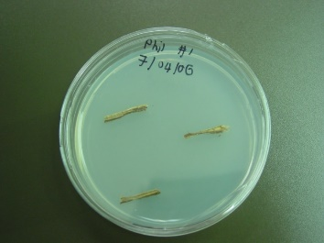
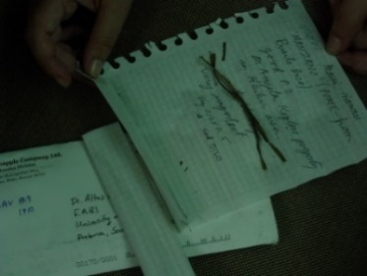

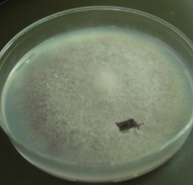
Infected vascular strands from the pseudostem in sterile blotting paper

- Sub-culture small areas of good Fusarium growth onto Streptomycin PDA. Use these cultures for single-sporing (need to grow for 2-3 days to be sure of healthy culture).
Streptomycin PDA

- Place a spore suspension onto water agar.
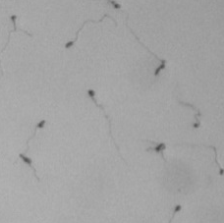

If isolation plates are not heavily contaminated, a shortcut can be taken by using Fusarium growth from the isolation plate for the spore suspension.

- After 24 hrs take germinated spores and place onto Streptomycin-PDA.

Streptomycin-PDA
Small plug of agar with a single germinated spore

- Once single spore cultures show normal Fusarium growth (should be visible after 4-5 days), choose only 1 single spore culture to represent each isolate and discard all other cultures. Assign this culture with a unique accession number. Sub-culture this isolate onto CLA, which will become the source for morphological, molecular and VCG identification, pathogenicity testing and storage.

Single spore culture
Morphological identification
Storage

VCG identification
Pathogenicity testing

Figure 4. Isolation of Fusarium oxysporum f. sp. cubense from diseased banana tissue.
Pathogen identification

Steps involved in laboratory diagnosis of Fusarium wilt of banana
- Receive specimen, record details and observations from grower/collector.
- Place symptomatic tissue on two Streptomycin-amended PDA plates, with four pieces per plate).
- Check morphology of the resultant fungal growth (macro- and microscopically).
- Sub-culture the Fusarium colony and prepare a spore suspension on WA.
- Select two germinated single spores to initiate monoconidial cultures.
- Assign a unique accession number to each sample and record in specimen book and Fusarium isolate database.
- The mono-conidial culture is used to:
- Inoculate two PDA plates for cultural identification.
- Initiate two CLA plates for morphological identification.
- Inoculate three chlorate medium (CM) plates to generate nit mutants for VCG tests.
- Inoculate one PDA plate for DNA analysis (will not be described in the field guide).
- Initiate one PDA plate for long-term storage.
- If necessary, prepare CLA slants for medium-term storage.
- If necessary, arrange for lyophilisation of isolate for long-term storage in collection.
- Conduct and record results of VCG analysis in database.
- Return written reply to grower/collector regarding the identity of the specimen.
- Maintain isolate collections and records in database.

Morphological characteristics of Fusarium oxysporum f. sp. cubense
- Produce abundant microconidia that are single-celled, and oval to kidney-shaped.
- Microconidia are produced in false heads on branched and unbranched monophialides.
- Macroconidia are few and sickle-shaped, with an attenuated apical cell and foot-shaped basal cell.
- Chlamydospores are present and form singly or in pairs.
- No perfect stage of F. oxysporum is known.
- On PDA, fungal colonies produce white aerial mycelia that may turn purple in the centre.
- Isolates may differ in their cultural morphology.
- Cream to orange sporodochia can form on carnation leaves on CLA.
Field and greenhouse trials

Field evaluation of banana varieties for Fusarium wilt resistance
Preparation of plots
It is important to consider banana production and disease management practices when selecting a location for field trials. The site should preferentially be located in a farmer’s field, and managed according to existing production practices. Fertilisers and irrigation need to be applied according to existing procedures. Particular care should be taken not to allow the trial site to serve as a source of contamination to bordering plantations. De-suckering and leaf removal should continue in the trial site as usual, but fungicides should not be applied for the duration of the trial. The experiment should run for the plant crop cycle and at least the first ratoon.
A proper knowledge of the history of a banana plantation is required when selecting trial sites for the evaluation of banana varieties for Fusarium wilt resistance. It is best to select an area where the disease is known to be well established and severe, and where a single Foc race is present. The inoculum in the soil should also be distributed as equally as possible. To achieve this, plants affected by Fusarium wilt need to be chopped up and ploughed back into the soil. To increase inoculum in fields, susceptible banana varieties can be grown in future trial sites for one cycle before being cut up and ploughed in. Alternatively, inoculum can be prepared in the laboratory and used to inoculate plants used in the trial. Inoculation of field sites should be conducted with extreme care, and only if necessary, without posing unnecessary risks to neighbouring fields. After the preparation of the field site, care should be taken to properly disinfect equipment used for the preparation of the soil, and also not to walk through the trial site unnecessarily during the execution of the trial. It is preferential that one specific team be appointed to maintain the field site and participate in the trial.

Selection of varieties and controls
When selecting varieties to be tested, it is important to target a specific Foc race and include both resistant and susceptible control varieties for that specific race (Table 1). It is also important to confirm the presence of the particular race in the trial site by characterising strains of Foc collected from diseased banana plants in that particular site. Three races of Foc are known, each one specific to a single or a range of banana cultivars (Table 1). For instance, when varieties are screened for resistance to Foc race 1, Gros Michel can be used as susceptible control and Cavendish as resistant control. If screened for resistance to Foc race 4, Cavendish can be used as susceptible control, and Calcutta-4 as the resistant control.
Table 1. Banana varieties used as resistant and susceptible checks for evaluation against races of Fusarium oxysporum f. sp. cubense.
Pathogen | Susceptible banana varieties | Resistant banana varieties
Foc race 1 | Silk, Gros Michel | Cavendish, Bluggoe, Calcutta-4
Foc race 2 | Silk, Bluggoe, Gros Michel | Cavendish, Calcutta-4
Foc race 4 | Silk, Cavendish, Gros Michel, Bluggoe | Calcutta-4

All plants used for field trials should be multiplied in vitro to ensure there is no contamination with Foc (asymptomatic infections) and other pests and diseases of banana. They should also be virus-indexed if possible. The plants should then be hardened-off under shade cloth in a nursery before field planting, either at the tissue culture facility where they were produced or at the farm where they will be planted. Special care should be taken not to contaminate the plants with Foc during the hardening-off stage by using Foc-free potting soil and irrigation water. Once plants reach a height of between 0.3 and 0.5 m, they can be taken to the field for planting. In the field, Fusarium wilt is expected to develop 3-12 mo after planting, depending on the susceptibility of varieties and inoculum load in the soils. After disease development, pseudostem samples should be collected for the isolation and characterisation of Foc strains.

Experimental design
Field experiments with Foc should be conducted by using a randomised complete block design (RCBD). A RCBD is used when a source of variation, such as the unequal distribution of Foc in banana soils, is present at the experimental site. By planting several plants from the same variety (treatments) in blocks that are randomised in the field, the experimental error caused by the unequal distribution of Foc in soils is reduced or eliminated. The effect of Foc on the treatments (banana varieties) are thus held constant, while the ability of the varieties to resist infection is allowed to vary.
Each block usually consists of between 10 and 50 plants, with 3-10 replications of each block. Control plants should always be included in the trial plan as a treatment. The number of plants/block and the number of replications/treatment will depend on the size of the field site and the cost of the trial. The greater the number of plants and blocks, the more accurate the outcome of the experiment will be. The level of infection of Foc in soils can also be determined by planting susceptible plants as a border row around each block, or even next to each of the plants tested in the trial.

Greenhouse evaluation of banana varieties for Fusarium wilt resistance
Different greenhouse screening methodologies have been developed and are used by researchers around the world (Table 2). Greenhouse trials, however, should not be considered a replacement for field trials when assessing disease management options. In fact, results obtained in the greenhouse can often conflict with those obtained in the field. It is thus important to select an appropriate greenhouse test to provide preliminary data before experiments are repeated in the field. Two issues should be considered:
- Greenhouse testing for disease resistance can be misleading, as disease development might disqualify entries from further use even though they can resist Fusarium wilt in the field. A good example is Cavendish bananas that often develop disease symptoms when inoculated with Foc race 1 in the greenhouse, but not in the field.
- The greenhouse method chosen for Fusarium wilt trials is important, as inoculum load, soil type, plant age and greenhouse conditions can all affect plants and the outcome of experiments. Preferentially, pilot trials should be conducted to first optimise experimental conditions when performing Fusarium wilt experiments in a new greenhouse. A number of greenhouse screening methods with different applications are known (Table 2), while damage scoring is based on external (Fig. 7) and internal (Fig. 8) symptoms.

Table 2. Greenhouse tests for banana Fusarium wilt and Fusarium oxysporum f. sp. cubense.
Trait tested for | Test used | Reference(s)
Disease resistance | In vitro bioassay | Wu et al., 2010
Disease resistance | Root dipping | Mohammed et al., 2000; Ribeiro et al., 2011
Disease resistance | Root dipping + millet seed | Dita et al., 2011
Disease resistance | Soil drenching | Smith et al., 2008
Disease resistance | Millet seed inoculation | Smith et al., 2008
Disease resistance | Biochemical and structural variations in infected plants | Morpurgo et al., 1994; De Ascensao and Dubery, 2000
Biological/ chemical control | Fungicides and sterilants | Nel et al., 2007
Biological/ chemical control | Biocontrol agents | Saravanan et al., 2003
Pathogen vs non-pathogen | Root dipping/ Immersion | Sun and Su, 1984; Ribeiro et al., 2011
Pathogen vs non-pathogen | Hydroponic cup test | Groenewald et al., 2006
Pathogen vs non-pathogen | Root dipping + millet seed | Dita et al., 2011
Race identification | Susceptible cultivars | Stover, 1990
Race identification | VCG analysis | Leslie and Summerell, 2006
Race identification | Molecular markers | Lin et al., 2009; Dita et al., 2011

Preparation of trials
Plants selected for greenhouse trials should preferentially be multiplied in a tissue culture facility. Depending on the nature of the trial conducted, the plantlets should then be grown in seedling trays, planting bags or pots to an appropriate and consistent size. To assess resistance against Foc races, trials should be grown in potting soil to a height of 20-30 cm before inoculation.
The Foc strain used for pathogenicity testing should be cultured from a single-spore which has been well-characterised before inoculation. It should then be plated onto ½ strength PDA and transferred to an appropriate medium to prepare inoculum. These media could be:
- Liquid medium: Spore suspensions are used to either dip seedlings in before planting to pots, or for drenching soils after planting the plants. The suspensions are prepared by transferring Foc into Amstrong media (Booth, 1971), or by collecting conidia from PDA plates and suspending these into sterile distilled water. The concentration of spores is usually adjusted to 1x10⁶ spores/ml for pathogenicity testing with Foc.
- Solid medium: PDA pellets with Foc can be grown on sterilised millet seeds or on a bran:sand mixture. These can then be mixed into the potting soil before the banana plants are transplanted into such soils, or added to the surface of the soil after transplanting.

Inoculation procedures for Fusarium wilt
- Inoculation by dipping: Tissue culture-generated plantlets must be planted in a double-pot system filled with sterilised sand or sand-soil mixture for hardening (Mohamed et al., 2000). When they reach a size of 20-30 cm, plants must be carefully uprooted, their roots washed, and plantlets inoculated by immersing their roots in a Foc conidial suspension for 2 hrs. Control plants must be immersed in clean water. The plants are then replanted into the pots and kept in the greenhouse until leaf symptoms develop. After that, plants should be uprooted and rated according to the Rhizome Discolouration Index (RDI) (Table 4).
- Millet grain inoculation: A known volume/weight of millet grain, inoculated with Foc, should be placed on sterile soil in the centre of half-filled pots. Well-rooted and hardened-off tissue culture plantlets should then be carefully removed from their pots, and their root tips wounded by gentle crushing at the base. These plantlets are then replanted on top of the millet grain, and the pot filled with sterile soil. Once leaf symptoms develop, plants can be rated according to the RDI.
- Dispensing method: A known volume of mycelial suspension (50 ml of 10⁶ conidia/mL) must be poured into a hole of approximately 3 cm deep to reach the root area of banana plantlets at the base of the pots. Watering must be suspended for 3 days to allow the fungal inoculum to settle in the soil and attach to plant roots. Once leaves show yellowing symptoms, plants should be removed and rated according to the RDI.
Scoring of Fusarium wilt trials

Data for disease progression in the field will be collected on a monthly basis from 3 mo after planting. In the greenhouse, however, symptom development should be monitored daily and disease ratings need to be conducted based on symptom development in the control plants.
Field evaluation of trials will be based on external leaf symptoms only. The reason why other external symptoms are not considered is because pseudostem splitting is not a reliable indicator of disease severity. The evaluation of internal symptoms, such as rhizome discolouration, requires destructive evaluation and can be performed only after harvest or at the end of the trial. In greenhouse trials, rhizome discolouration would be the better measure of disease development, as leaf symptoms develop much later than rhizome symptoms.
External disease symptoms can be measured on a 1-5 scale in the field (Table 3, Figs. 5-6) and in pots (Figs. 7-8). In some cases, early symptoms of Fusarium wilt (Level 2) can be incorrectly identified. In such cases, the disease will not progress to Level 3 and beyond. In other cases, the disease could be correctly identified, but the plants will respond to infection and the disease will disappear as new leaves emerge and older leaves are trimmed away. In most cases, however, the disease will progress beyond Level 2. Once it reaches Level 4, the plant will eventually die. It is thus important to not only rate the level of disease in the field, but also the rate at which the disease develops. Since disease development depends on soil and environmental factors, an average rating per block will be determined, and the treatments compared by statistical analysis of a replicated trial.

Table 3. Disease rating scale for the evaluation of external symptoms of Fusarium wilt on banana.
Disease rating scale | Symptoms observed
1 | No visual leaf symptoms
2 | 0-33% of older banana leaves turning yellow
3 | 34-66% of older leaves turning yellow, with some hanging down the pseudostem
4 | 76-100% of leaves turning yellow and necrotic, with leaves hanging down the pseudostem
5 | Plant dead, with brown leaves hanging down pseudostem

Susceptibility of banana varieties to Foc can be measured in two ways: 1) by determining disease incidence and 2) by determining disease severity. In addition, resistance can be measured by considering disease progression over time. The criteria that need to be fulfilled when measuring the effect of Fusarium wilt on bananas in the field includes the reliability, practicality, time and cost efficiency of the experiment, and data collection.
Disease incidence, severity and progression are calculated as follows:
Disease incidence indicates the proportion or percentage of plants diseased within a sampling unit (Seem, 1984). It is calculated by dividing the number of Fusarium wilt-affected plants by the total number of plants at a specific time point.
Disease severity quantifies the amount of plant tissue affected. It may also be assessed by assigning a disease severity category or class value to each observed plant. It is calculated according to Sherwood and Hagedorn (1958) as:
Disease severity (%) = Σ [(number of plants in disease scale category) x (specific disease scale category) / (total number of plants) x (maximum disease scale category)] x 100
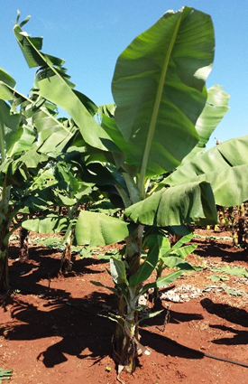
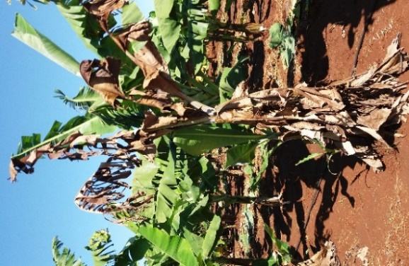
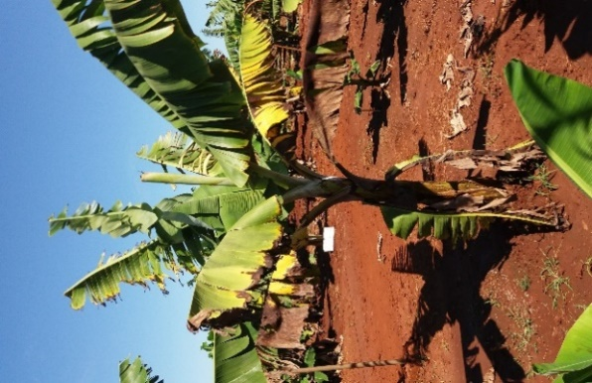
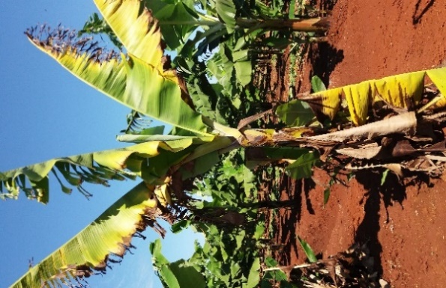
Rating: 4
Rating: 2
Rating: 3
Rating: 1

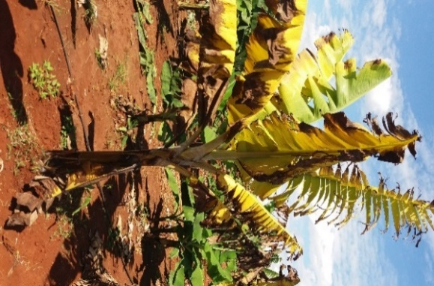
Rating: 5

Figure 5. Visual and descriptive disease rating scale for the evaluation of external symptoms of Fusarium wilt on Cavendish/Mchare bananas in the field.

Disease progression indicates the increase in disease incidence and/or severity over time, and can be measured by comparing disease progress curves of the different treatments.

Additional information can also be collected during disease ratings of Fusarium wilt. These include the time from planting to death of plants and yield. Field trials can further be used to assess management options such as biological, chemical and cultural control. It is not recommended to use multiple fields for the same experiment, as the initial inoculum in fields may differ.

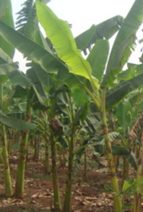
Rating: 1

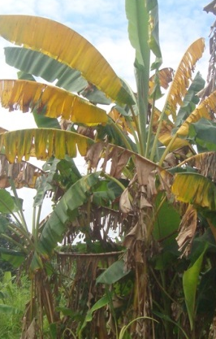
Rating: 4
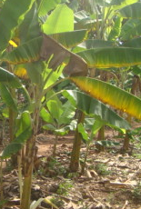
Rating: 2

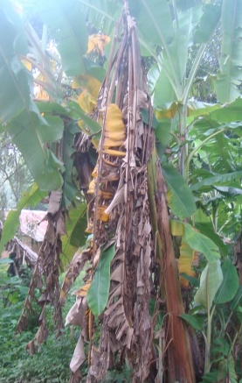
Rating: 5
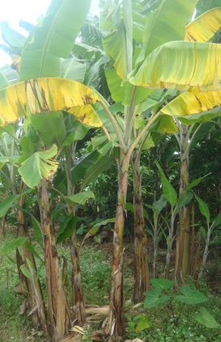
Rating: 3

Figure 6. Visual and descriptive disease rating scale for the evaluation of external symptoms of Fusarium wilt on Sukari Ndizi/Pisang Awak bananas in the field.

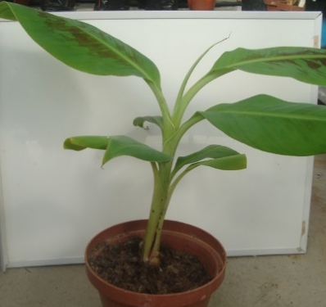
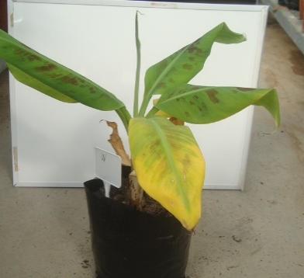
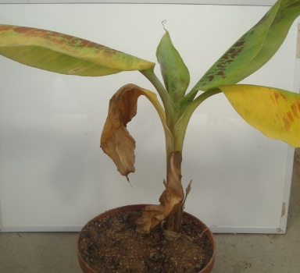
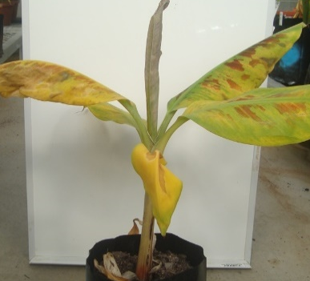
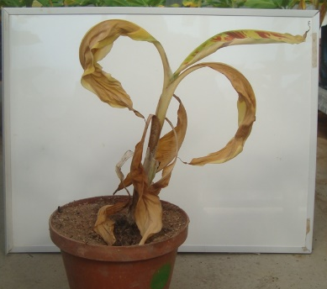

Rating: 1
Symptoms: No yellowing of leaves

Rating: 2
Symptoms: Yellowing of < 1/3 of the leaves

Rating: 3
Symptoms: Yellowing of 1/3 to 2/3 of leaves

Rating: 4
Symptoms: Yellowing of > 2/3 of leaves

Rating: 5
Symptoms: Plant dead

Figure 7. Rating of external symptoms of banana Fusarium wilt on pot plants in the greenhouse.

Table 4. Disease rating scale for the evaluation of internal symptoms of Fusarium wilt of banana.
Disease rating scale | Symptoms observed | Disease rating scale | Symptoms observed
1 | No internal symptoms | 4 | 1/3-2/3 Discoloured
2 | Few internal spots | 5 | >1/3 Discoloured
3 | <1/3 Discoloured | 6 | Entire inner rhizome

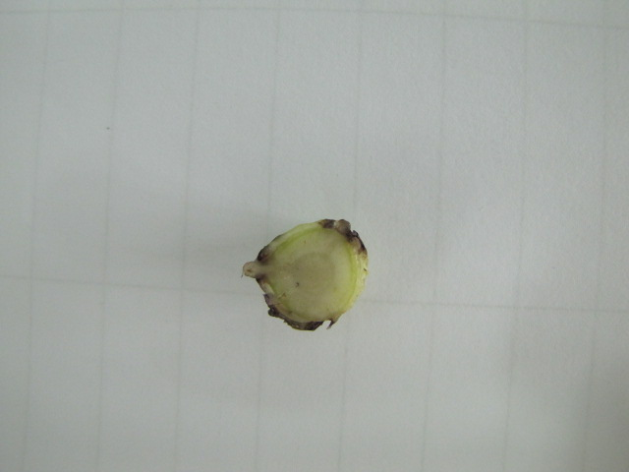
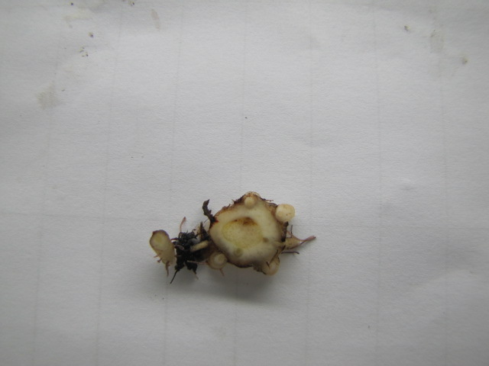
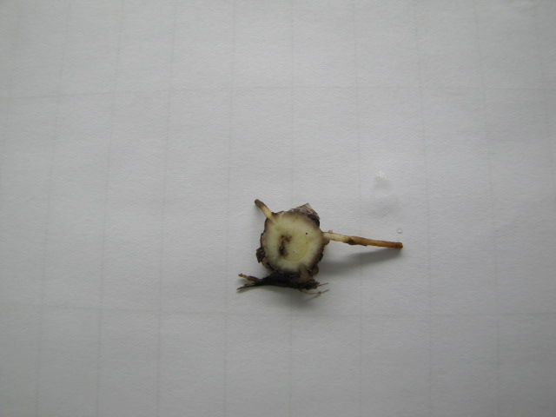
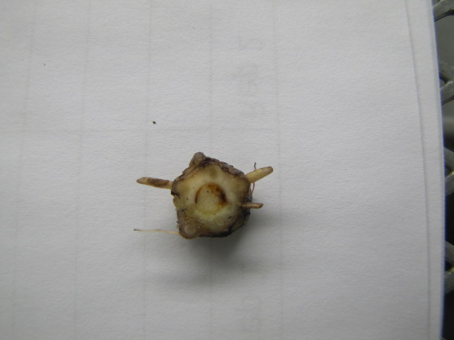
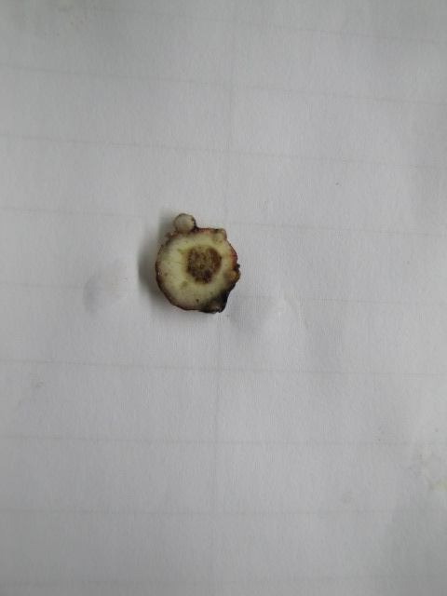
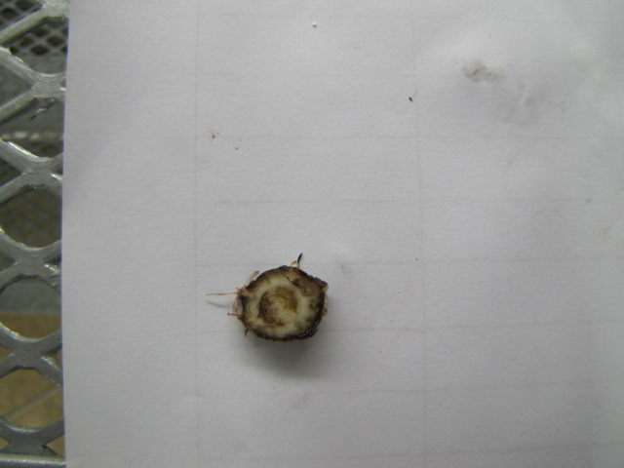
Rating: 1
Rating: 6
Rating: 5
Rating: 4
Rating: 3
Rating: 2

Figure 8. Rating of internal symptoms of banana Fusarium wilt in pot plants according to the rhizome discolouration index (RDI) in the greenhouse.
References and useful reading
Ainsworth, G.C. 1971. Ainsworth and Bisby’s Dictionary of the Fungi. 6th ed. Commonwealth Mycological Institute, Kew, Surrey, England. 663 pp.
Blomme, G., Ploetz, R., Jones, D., De Langhe, E., Price, N., Gold, C., Geering, A., Viljoen, A., Karamura, D., Pillay, M., Tinzaara, W., Teycheney, P.-Y., Lepoint, P., Karamura, E. and Buddenhagen, I. 2013. A historical overview of the appearance and spread of Musa pests and pathogens on the African continent: highlighting the importance of clean Musa planting materials and quarantine measures. Annals of Applied Biology 162: 4-26.
Booth, C. 1971. The Genus Fusarium. Commonwealth Mycological Institute, Kew, UK.
De Ascensao, A.R. and Dubery, I.A. 2000. Panama disease: cell wall reinforcement in banana roots in response to elicitors from Fusarium oxysporum f. sp. cubense race four. Phytopathology 90: 1173-1180.
Dita, M.A., Waalwijk, C., Paiva, L.V., Souza, Jr. M.T. and Kema, G.H.J. 2011. A greenhouse bioassay for the Fusarium oxysporum f. sp. cubense x ‘Grand Naine’ (Musa, AAA, Cavendish subgroup) interaction. Acta Horticultura 897: 377-380.
Dzomeku, B.M., Bam, R.K., Adu-Kwarteng, E., Ankomah, A.A. and Darkey, S.K. 2008. Comparative study on the agronomic, nutritional values and consumer acceptability of FHIA-21 (tetraploid hybrid) and Apem (triploid French plantain) in Ghana. American Journal of Food Technology 3: 200–206.
Gaidashova, S., Karemera, F. and Karamura, E. 2008. Agronomic performance of introduced banana varieties in lowlands of Rwanda. African Crop Science Journal 16: 9-16.
Groenewald, S., Van den Berg, N., Marasas, W.F.O. and Viljoen, A. 2006. Biological, physiological and pathogenic variation in a genetically homogenous population of Fusarium oxysporum f. sp. cubense. Australasian Plant Pathology 35: 401-409.
Karamura, E., Frison, E., Karamura, D.A. and Sharrock, S., 1998. Banana production systems in eastern and southern Africa. Pages 401-412 in: Bananas and Food Security. (Eds. C. Picq, E. Foure and E.A. Frison). Proceedings of an International Symposium held in Douala, Cameroon. INIBAP, Montpellier, France.
Karangwa. 2015. Diversity and population structure of Fusarium oxysporum f. sp. cubense in East and Central Africa. PhD dissertation. Stellenbosch University, South Africa, 160 pp.
Leslie, J.F. and Summerell, B.A. 2006. The Fusarium laboratory manual. Blackwell Publishing. Iowa, USA. pp 1-388.
Lin, Y.-H., Chang, J.-Y., Liu, E.-T., Chao, C.-P., Huang, J.-W.and Chang, P.-F. L. 2009. Development of a molecular marker for specific detection of Fusarium oxysporum f. sp. cubense race 4. European Journal of Plant Pathology 123: 353-365.
Mohamed, A.A., Mak, C., Liew, K.W. and Ho, Y.W. 2000. Early evaluation of banana plants at nursery stage for Fusarium wilt tolerance. Pages 174-185 in: A.B. Molina, N.K. Masdek and K.W. Liew (eds.), Banana Fusarium wilt management: towards sustainable cultivation, Proceedings of the International workshop on the banana Fusarium wilt disease, Genting Highlands Resort, Malaysia, 18-20 October 1999.
Morpurgo, R., Lopato, S., Afza, R. and Novak, F. 1994. Selection parameters for resistance to Fusarium oxysporum f. sp. cubense race 1 and race 4 on diploid banana (Musa acuminata Colla). Euphytica, 75: 121-129.
Msogoya, T.J., Maerere, A.P., Kusolwa, P.M. and Nsemwa, L.T. 2006. Field performance of improved banana cv. FHIA 17 and FHIA 23 in the eastern zone of Tanzania. Journal of Agronomy 5: 533-535.
Nel, B., Steinberg, C., Labuschagne, N. and Viljoen, A. 2007. Evaluation of fungicides and sterilants for potential application in the management of Fusarium wilt of banana. Crop Protection 26: 697-705.
Nelson, P.E., Toussoun, T.A. and Marasas, W.F.O. 1983. Fusarium species: An illustrated manual for identification. The Pennsylvania State University Press, London. 193 pp.
Ribeiro, L.R., Amorim, E.P., Cordeiro, Z.M., Silva, S. de Oliveira e and Dita, M.A. 2011. Discrimination of banana genotypes for Fusarium wilt resistance in greenhouse. Acta Horticulturae 897: 381-385.
Rowe, P.R. and Rosales, F.E. 2000. Conventional banana breeding in Honduras. Pages 143-172 in: Diseases of Banana, Abaca and Enset (Ed. D.R. Jones). CABI Publishing, New York, USA.
Saravanan, T., Muthusamy, M. and Marimuthu, T. 2003. Development of integrated approach to manage the fusarial wilt of banana. Crop Protection 22: 1117-1123.
Sherwood, R.T. and Hagedorn, D.J. 1958. Determining common root rot potential of pea fields. Wisconsin Agricultural Experimental Station Research Bulletin 531: 12.
Smith, L.J., Smith, M.K., Tree, D., O’Keefe, D. and Galea, V.J. 2008. Development of a small-plant bioassay to assess banana grown from tissue culture for consistent infection by Fusarium oxysporum f. sp. cubense. Australasian Plant Pathology 37: 171-179.
Stover, R.H. 1962. Fusarial wilt (Panama disease) of bananas and other Musa species. Commonwealth Mycological Institute, Kew, Surrey, UK.
Stover, R.H. 1990. Fusarium wilt of banana: some history and current status of the disease. Pages 1-7 in: Fusarium wilt of banana. (Ed. R.C. Ploetz). APS Press, St Paul, MN, USA.
Sun, E.J. and Su, H.J. 1984. Rapid method for determining differential pathogenicity of Fusarium oxysporum f. sp. cubense using banana plantlets. Tropical Agriculture 61: 7–8.
Wu, Y., Yi, G. and Peng, X. 2010. Rapid screening of Musa species for resistance to Fusarium wilt in an in vitro bioassay. European Journal of Plant Pathology 128: 409-415.

Yellow and Black Sigatoka

Background

Sigatoka disease of banana is a complex of foliar diseases that are caused by fungi belonging to the genus Pseudocercospora (previously called Mycosphaerella). Three species are associated with Sigatoka disease and these are P. fijiensis, causal agent of black Sigatoka (Stewart et al., 1999), P. musicola causing yellow Sigatoka (Stover and Simmonds, 1987), and P. eumusae that causes Eumusae leaf spot (Carlier et al., 2000; Crous and Mourichon, 2002). These species are recognised as among the most important constraints to banana production worldwide (Carlier et al., 1996). Damage caused by Sigatoka pathogens is manifested as necrotic leaf lesions that reduce the functional leaf area and photosynthetic capacity, resulting in reduced crop yield and fruit quality. This accounts for banana yield losses ranging from 20-50% (Stover, 1983; Crous and Mourichon, 2002).
Of the three Pseudocercospora species associated with Sigatoka disease, P. fijiensis is considered the most damaging (Carlier et al., 2000). Apart from reducing the photosynthetic capacity of the plant, the pathogen also induces premature ripening of the fruit, which seriously affects fruit export (Stover, 1991). Banana yield losses of 30-50% arising from black Sigatoka have been reported in Uganda (Tushemereirwe et al., 2000). Pseudocercospora fijiensis is classified as a high-risk pathogen because of its short disease cycle, capacity to sporulate profusely and capacity to reproduce sexually, giving rise to new pathotypes (Ploetz, 2000). The pathogen overwinters in plant debris left in the field, and windborne ascospores are the primary source of infection. Re-infections within a plantation arise from conidia washed off by rain splashes and heavy dew. Long-distance spread of the pathogen is through infected planting material (suckers) and leaves, which are often used as packaging materials in developing countries (Ploetz and Mourichon, 1999). Disease dispersal and development is favoured by high moisture and humidity.
Pseudocercospora fijiensis in Africa was first identified in Gabon in 1978 (Frossard, 1980). After this, the disease spread to other West African countries including Cameroon, Côte d’Ivoire, the Democratic Republic of Congo, Nigeria and Ghana. Introduction into East Africa is believed to be a separate event (Carlier et al., 2000) through the island of Pemba in 1987. From there it rapidly spread to Zanzibar and to the mainland of Tanzania (Dabek and Waller, 1990).The disease is currently present in Rwanda and Burundi, (Sebasigari and Stover, 1988), Kenya (Kung'u et al., 1992) and Uganda (Tushemereirwe and Waller, 1993).

Symptoms

Black and yellow Sigatoka cause similar symptoms depending on the cultivar infected, stage of disease development and the season of the year (winter or summer) (Johanson, 1993).

Black Sigatoka
Black Sigatoka disease progression (Fig. 9), as described by Stover and Simmonds (1987), include the following stages:
Stage 1: Faint, minute, reddish-brown specks on the lower surface of the leaf.
Stage 2: Specks elongate, becoming slightly wider to form narrow reddish-brown streaks.
Stage 3: Streaks change colour from reddish brown to dark brown or black, sometimes with a purplish tinge, clearly visible at the upper surface of the leaf.
Stage 4: The streaks broaden and become more or less fusiform or elliptical in outline, and a water-soaked border appears around each lesion.
Stage 5: The dark brown or black centre of each lesion becomes slightly depressed and the water-soaked border becomes more pronounced.
Stage 6: The centres of the lesions dry out becoming light grey, with a bright yellow zone forming between them and the normal green colour of the leaf. The lesions remain clearly visible after the leaf has become necrotic because of their light-coloured centre and dark border.

Yellow Sigatoka
Yellow Sigatoka symptoms are characterised by oval to round necrotic lesions, which first appear pale yellow on the lower surface of the leaf (Meredith and Lawrence, 1970). This differentiates it from black Sigatoka at early stages of lesion development (e.g. Stages 1 and 2). At later stages, the use of a microscope is required to look at conidiophores and conidial morphology to differentiate the two pathogens. Descriptions of the development of individual lesions of Sigatoka disease over the years were summarised by Meredith and Lawrence (1970). Brun’s (1963) description is similar to that of Leach (1946), except that Brun excluded Leach’s 5th stage (second spot stage).

Meredith and Lawrence (1970) described Yellow Sigatoka symptom progression (Fig. 9) as follows:
Stage 1: This stage is characterised by the appearance of very small light green dots or dashes of approximately 1 mm in length.
Stage 2: Stage 1 dots and dash elongates into a light green streak several mm long.
Stage 3: The colour of the streak changes to rusty brown. The streak is elongated and widens slightly, but the border is ill-defined.
Stage 4: The streak becomes more elliptical, has a definite spot with a sunken dark brown centre and is often surrounded by a yellow halo. Conidia and conidiophores are produced.
Stage 5: The final stage has a grey, dried out centre and an obvious black margin. This black margin can still be seen even after the leaf has dried out.

Other Leaf spots
Eumusae leaf spot, first reported in South and Southeast Asia in 2000, is caused by P. eumusae (Carlier et al., 2000; Crous and Mourichon, 2002). In Africa, the pathogen has been reported in Nigeria where it was found to co-exist with P. fijiensis (Zandjanakou et al., 2009). Little is known about P. eumusae but morphologically it is similar to P. musicola.
Several fungal pathogens can induce leaf spots on banana that are similar in appearance to those caused by P. fijiensis and P. musicola. These other pathogens, however, can easily be distinguished from the Sigatoka pathogens by using light microscopy, as they are morphologically distinct from Pseudocercospora spp.

 | Black Sigatoka | Yellow Sigatoka
Stage 1 |  | 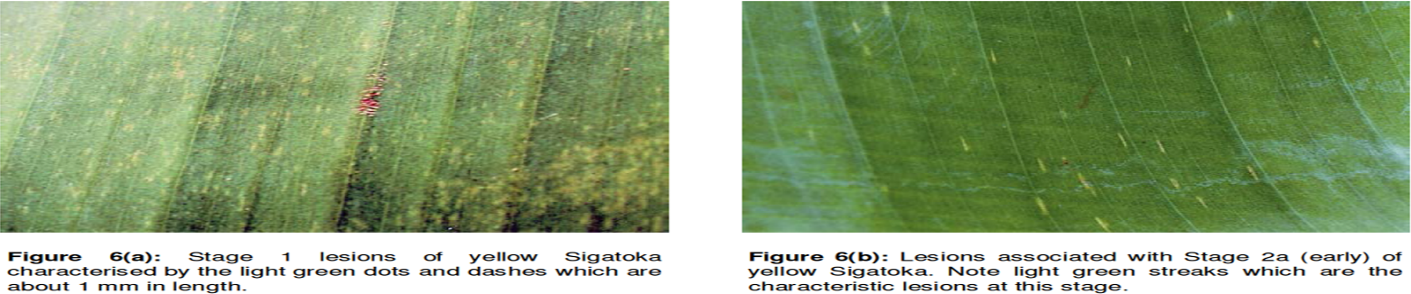
Stage 2 | 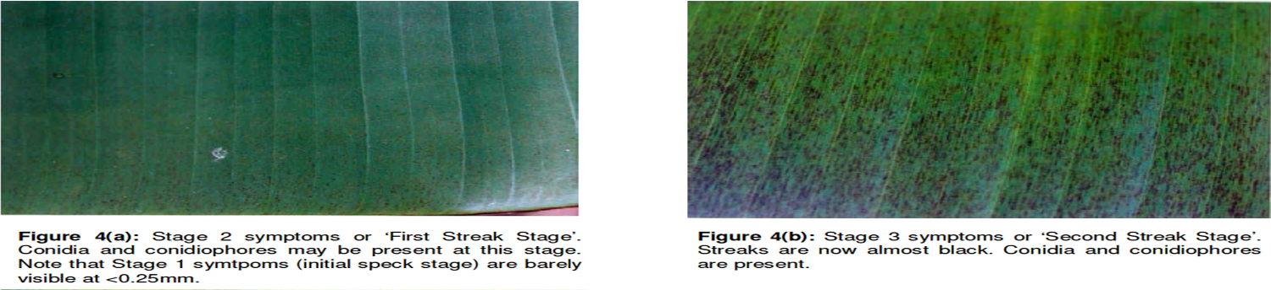 | 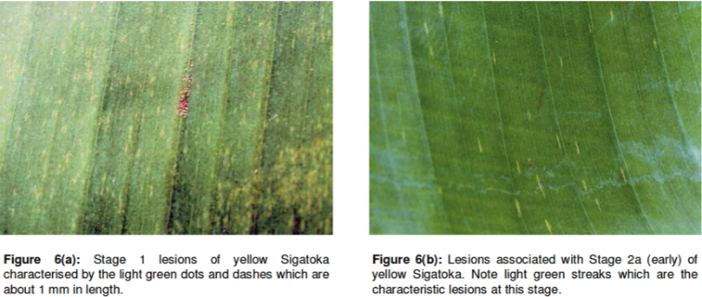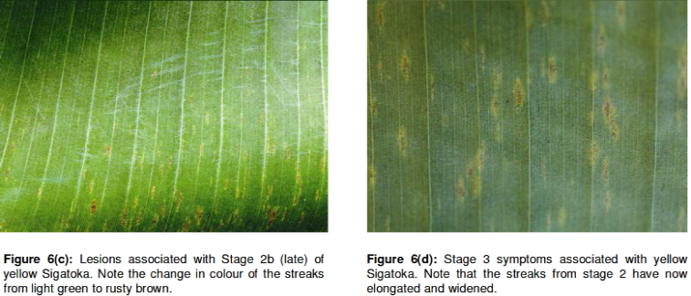  b  a
Stage 3 | 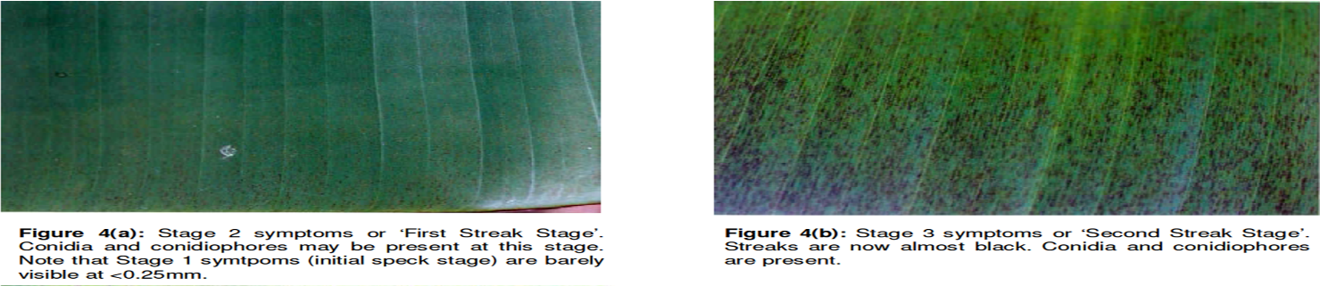 | 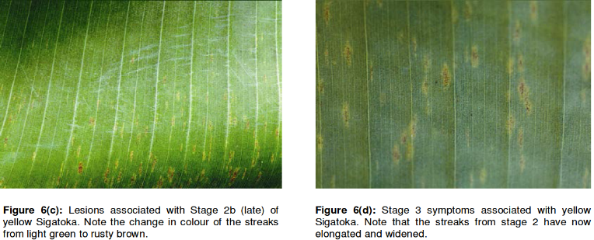
Stage 4 | 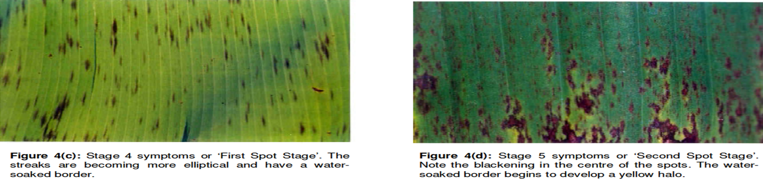 | 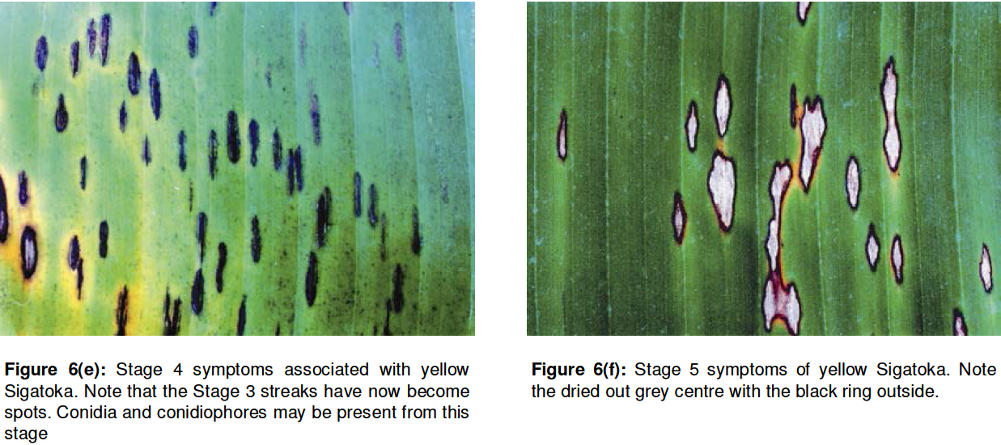
Stage 5 | 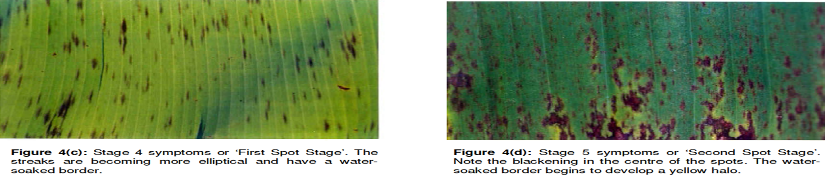 | 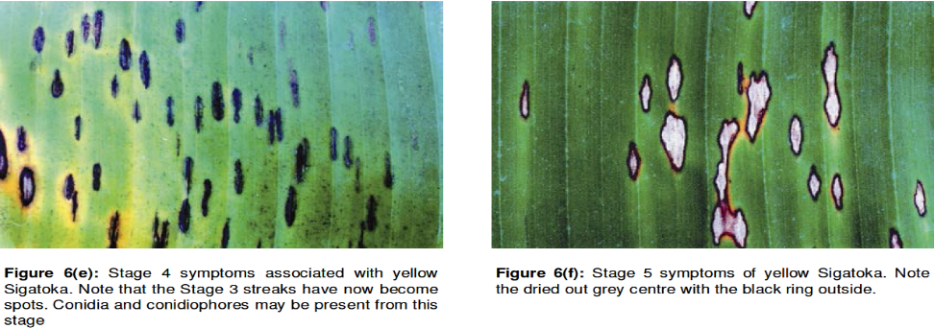
Stage 6 | 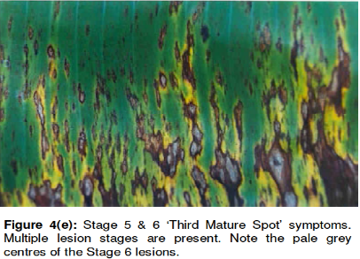
Figure 9. Pictorial representation of the different stages of yellow and black Sigatoka.
Disease cycle and epidemiology

The disease cycle for P. fijiensis and P. musicola is similar (Fig. 10), with minor differences. Black Sigatoka develops faster and is more aggressive than yellow Sigatoka, as seen by the earlier appearance of spots. Inoculation studies conducted in Honduras demonstrated that spotting associated with P. fijiensis infections appear 8-10 days faster than that associated with P. musicola infections. Ascospore maturation time is also shorter at 2 wks for P. fijiensis compared with 4 wks for P. musicola (Stover, 1980). Due to the relatively shorter disease cycle, P. fijiensis produces considerably less conidia than P. musicola. Thus, ascospores are the main dispersal agent for this pathogen (Stover, 1980).
Both conidia and ascospores are important for dispersal of P. musicola (Stover, 1971). Ascospores are windborne and consequently more important in the movement of the pathogen over longer distances, while conidia are important for short distance spread (Stover, 1980). Infections from conidia are characterised by a distinctive line-spotting pattern that runs down the full length of the cigar leaf cylinder, resulting in a line of infection (Meredith, 1970). Infection from ascospores usually results in a characteristic leaf tip infection. This is because deposition of ascospores carried in wind currents are generally deposited at the terminal end of leaves (Meredith, 1970).

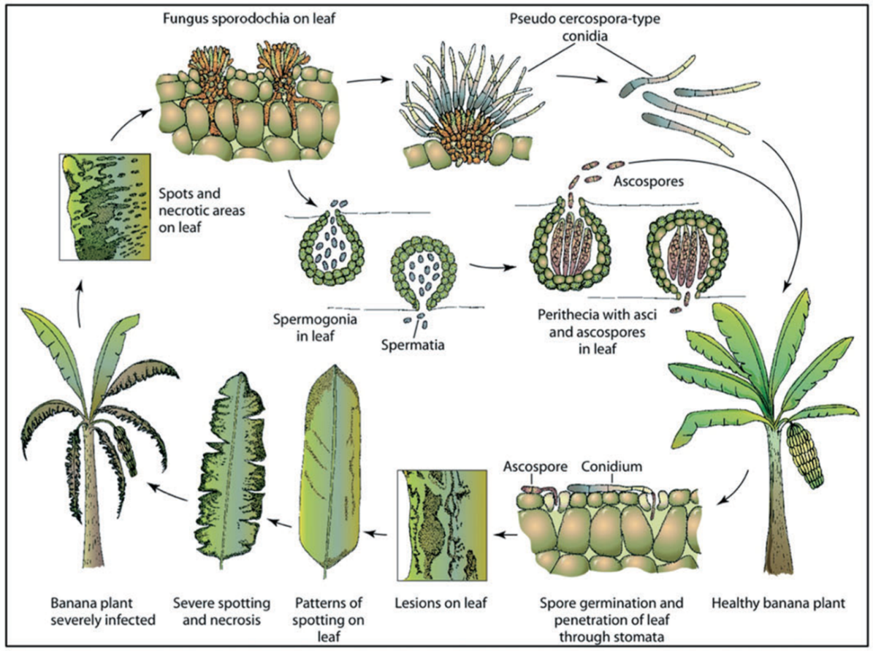
Figure 10. Life cycle Pseudocercospora fijiensis, causal agent of black leaf streak disease of banana (Churchill, 2011).
Sample collection

Sampling from the diseased host plant in the field
Samples collected from banana leaves should consist of a leaf section bearing numerous Sigatoka disease lesions at Stages 2-4 (Brun, 1963). For ascospore discharge, samples should be taken from the necrotic parts of the leaves. Samples should be kept in heavy paper bags or wrapped in paper (e.g. newsprint) if the sampled fields are close and can be transported to the laboratory quickly. Avoid using plastic bags, as this increases humidity and promotes growth of bacteria and deterioration of samples. When collecting samples in fields at distance from the laboratory, or if sample processing is likely to be delayed, the samples should be pressed between cardboards for preservation (Fig. 11). Notes to be taken for each sample include:
- Sample identification number (one sample number per plant).
- Date sampled.
- The variety of the host plant, including local names (and uses if known).
- Site of sampled plants: garden, commercial plantation, village or elsewhere.
- Location (e.g. name of province/state, distance and direction from nearest town, name of road, name of property if sample is from a commercial plantation etc.).
- A map with sample numbers marked on it or GPS coordinates can be very useful.
- Whether the plants sampled are growing in a garden, commercial plantation, village or wild situation. GPS coordinates and altitude.
- Collector’s names.
- Other useful observations, such as source of the planting material, number of plants affected, other varieties growing around the diseased plant and if diseased or healthy?
- Disease assessment parameters (see below).

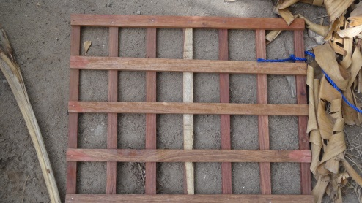
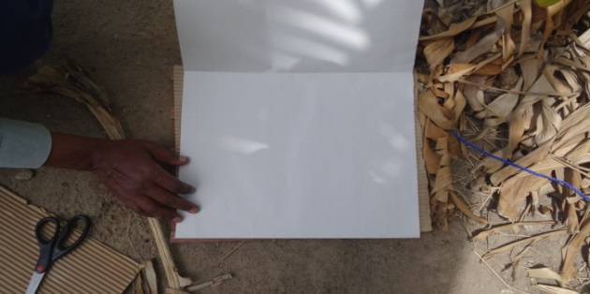
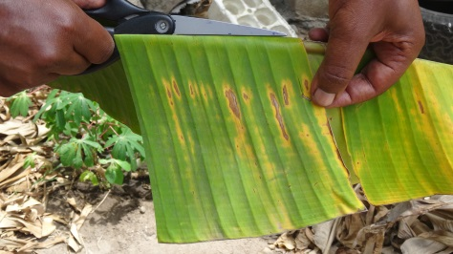
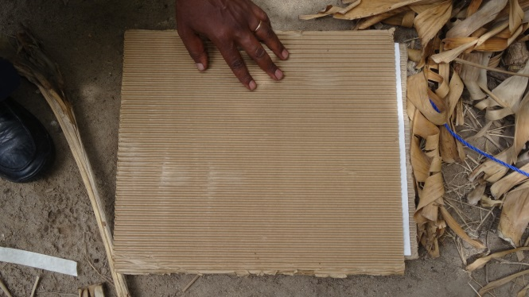
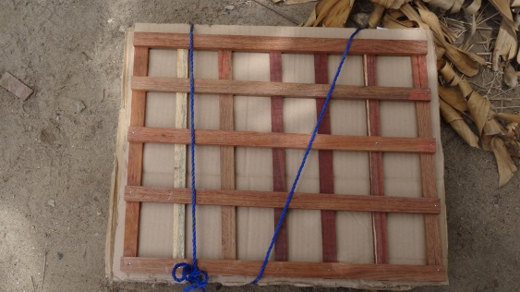
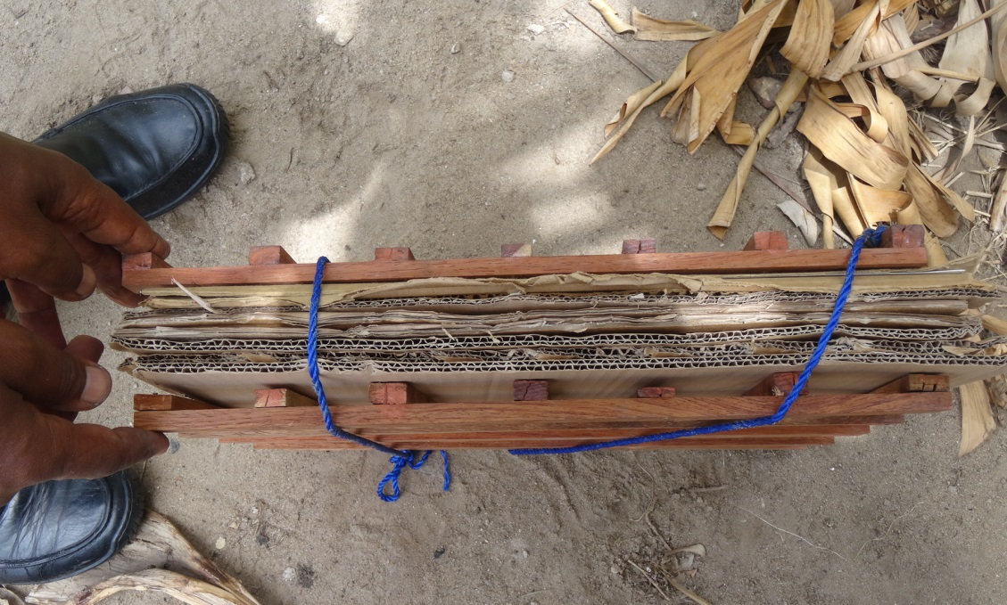
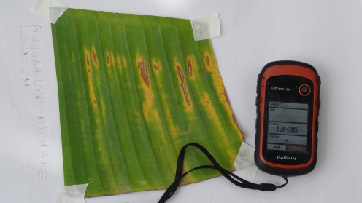
2. Assemble Herbarium press: place piece of cardboard on the press, and newspaper, on which to fix the leaf sample.
1. Sample collection: cut a piece of leaf with clear symptoms and some healthy green tissue. Avoid heavily necrotic regions. Sterilise equipment to avoid contamination.

4. Cover sample with newspaper and a piece of cardboard. This will separate samples and avoid cross-contamination. The newspaper will absorb moisture; cardboard will press the sample for preservation. Many samples can be collected on a single press.

5. When sampling is finished, tie samples together (tightly) so they are pressed. Take samples to the laboratory. Samples can be stored on the shelf for long periods without losing viability. It is important to remove moisture to avoid sample rotting.

3. Fix sample on newspaper using masking tape to firmly hold the sample in place; write necessary information: e.g. GPS coordinates, variety, farmer name, location, date, collector, etc.

Figure 11. Sampling banana leaves with Sigatoka symptoms for identification of Pseudocercospora spp.

Pathogen isolation

Several protocols / methods can be used to obtain pure isolates of Pseudocercospora species. The choice of the method / protocol depends on availability of materials required for isolation. Following isolation, sporulation is induced and the resulting fungal structures (conidiophores and conidia) are used for identification of Pseudocercospora spp. Pure isolates can be obtained by directly plating symptomatic leaf tissue on PDA media, picking conidia from sporulating lesions from the field, and discharging ascospores from leaf lesions onto media.

Direct isolation
To produce cultures directly from leaf material, early disease development stages are required (Fig. 12). Surface sterilise leaf material and then excise small pieces of tissue. Place these directly onto PDA media in Petri dishes.

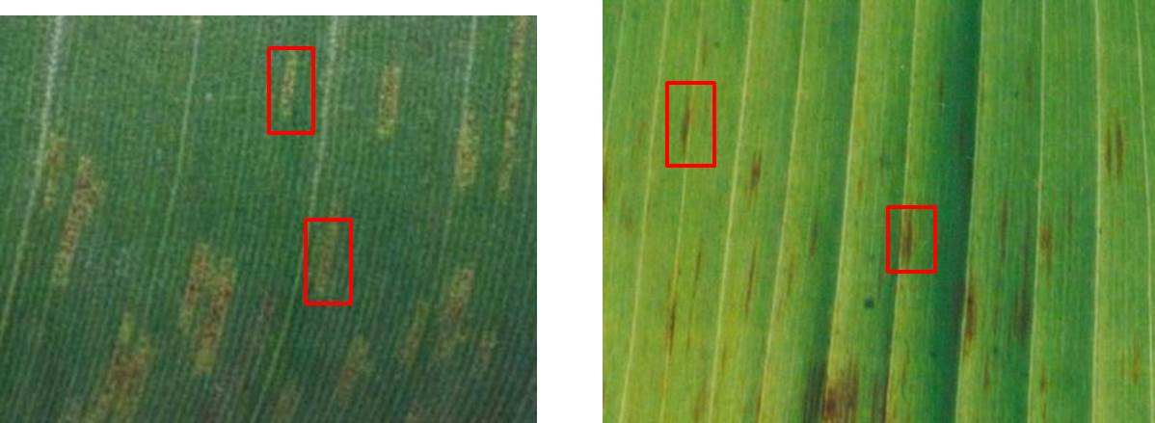
Figure 12. Lesion stage required for direct isolation of Pseudocercospora spp. (P. musicola and P. fijiensis / P. eumusae) from symptomatic banana leaf tissue.

Procedure:
- Select leaf material containing Stage 2 lesions of suspected P. musicola, or Stage 2-3 for P. fijiensis or P. eumusae, and cut them into 1-2 cm squares.
- Immerse the tissue into a beaker containing 1% sodium hypochlorite for 1 min, remove and wash five times with sterile distilled water, blot dry using sterile blotting paper.
- Using a sterile scalpel blade, make incisions on either side of the lesion, taking care not to cut right through the leaf piece.
- Excise epidermal pieces of tissue (approximately 2 mm²), and plate onto PDA.
- Seal the Petri dish with Parafilm® and incubate at 25ºC for 10 days.
- Transfer small portions (hyphal tips) of the culture to V8 media to induce conidia production.
- Mount the conidia on a glass slide and observe under a compound microscope to identify Pseudocercospora species (Table 5).

Picking conidia from sporulating lesions to establish single conidia isolates
Pure isolates of Pseudocercospora can be established from single conidia obtained directly from infected banana leaves.

Procedure 1 for conidial isolation:
- Surface sterilise leaves (4 × 4 cm squares) with Stages 2-5 lesions (Fouré, 1994) with 20% commercial NaHCl bleach plus Tween 20 (500 μl/L) for 10 min.
- Dry the sterilised leaves with sterile paper towels.
- Place dried sterile leaf pieces on top of sterile filter paper soaked with sterile distilled water.
- Seal inside a Petri dish with wet filter paper.
- Incubate plates at 20°C for up to 5 days to induce conidia production.
- Using a small plug of WA, lightly brush the top of the sporulating lesion and place the agar piece in an Eppendorf tube with sterile distilled water.
- Vortex for 2 min to dislodge the spores in the water and spread 200 μl of water on WA and incubate for 8-12 hrs at 25°C with continuous white light.
- Under a stereo microscope, locate a germinating spore, transfer to a fresh WA Petri dish to start a pure culture of Pseudocercospora spp., and incubate at 25ºC for 10 days.
- Transfer small portions (hyphal tips) of the culture to V8 media to induce conidia production for the identification of Pseudocercospora spp. using morphological features (Table 5).

Procedure 2 for conidial isolation (Conde-Ferráez et al., 2008)
- Use leaf tissues with Stage 4 streaks for conidia production.
- Cut approximately 2 x 2 mm pieces and place on a stainless steel sieve.
- Sterilise by gentle shaking, first in absolute ethanol for 30 s, then 5 min in 10% (v/v) NaHCl and then wash three times (2 min each) in sterile distilled water.
- Transfer the leaf pieces to PDA plates containing 0.001 g/l each of penicillin and streptomycin and incubate for 4-6 days at 25°C under 12 hr / 12 hr alternating light and dark conditions to allow production of conidia.
- View conidia under a binocular microscope and transfer with a sterile fine needle to a fresh plate of PDA containing penicillin and streptomycin.
- Transfer Pseudocercospora colonies to PDA plates with a sterile scalpel after 6–10 days.

Generation of single-spore cultures
- Cut two pieces of a Pseudocercospora culture on ¼ PDA (approximately 6 x 6 mm), and aseptically transfer them to a 9-ml McCartney bottle or 1.5-ml Eppendorf tube containing sterile distilled water. Swirl the bottle (tubes) gently to wash the spores into suspension.
- Flame-sterilise a loop, and transfer 1-2 loops of the spore suspension to a WA plate.
- Use the flamed loop to streak out the spore suspension across the plate either in parallel lines or in the 16-streak method used in microbiology. This separates the conidia from each other to enable single, separated, germinated spores.
- After 18-24 hrs, single spore are located using a stereo microscope by looking for a germ tube growing from them.
- Once a single germinated spore is observed, use a flamed scalpel to transfer the spore to a ¼-strength PDA plate. Repeat this procedure four times for each isolated culture to ensure that a pure monoconidial culture is obtained.
- After 3 days, choose a culture with typical Pseudocercospora growth as representative isolate and discard the others. This culture should immediately be transferred to agar slants for short-term storage, or filter paper (see procedure below) for long-term storage.

Production of cultures from ascospores
Cultures of Pseudocercospora spp. can be derived from ascospores (sexual stage). These cultures can then be used to produce conidia (asexual stage) for species identification (Fig. 13). Several methods are used; the choice depends on material availability and experience of the researcher. All work very well and achieve the desired objective. The ascospore method requires dried leaf tissue containing necrotic lesions which need to be wetted, causing the perithecia to rupture and eject their ascospores (Fig. 13). Germinated ascospores are transferred to PDA and subsequently sub-cultured onto sporulation medium to produce conidia for use to identify Pseudocercospora spp. (Table 5).

Procedure for ascospore ejection (Twizeyimana et al., 2007)
- Select leaf tissue with necrotic lesions (most likely to contain ascospores), particularly those with grey centres which contain small black spots (perithecia) (Fig. 13).
- Banana leaf samples must be very dry. If necessary, leave tissue at room temperature for 2-3 days to dry. Dried tissue of up to 2 mo old can be used for ascospore ejection.
- Immerse leaf tissue into a 2% solution of NaHCl for 2 min. This is to reduce any surface fungi that may be present. Rinse in sterile distilled water to remove excess NaHCl.
- Incubate leaf material with black streaks or grey spots in plastic bags containing moist tissue paper for 24–48 hrs.
- Cut leaf tissue containing coalescing, necrotic lesions into approximately 5 x 5 cm pieces.
- Place leaf tissue into beakers that contain sterile distilled water for 20-30 min and drain excess water. Paste tissues on a 90-mm-diameter Whatman filter paper and then insert the filter paper into a Petri dish lid.
- Invert a 3% WA plate so that the upper leaf surface is closest to the agar surface. Outline the location of the leaf tissue pieces on the bottom of the agar plate with a permanent marker pen to assist location of germinated ascospores following incubation.
- Leave the Petri dish for 1-2 hrs for the leaf piece to discharge spores onto the agar.
- Remove the filter paper and leaf piece, seal the Petri dish with Parafilm® and incubate at 25°C under 12 hr alternating light and dark for 24-48 hrs for the spores to germinate.
- Pick germinated spores characteristic of Pseudocercospora spp. (one or two terminal germ tubes) off the surface of the agar using a sterile fine needle under a dissecting microscope fitted with an illuminated stage plate. Select only ascospores that have one or two terminal germtubes.
- Using a sterile scalpel blade, dissect a small agar square containing the germinated ascospore and transfer onto a fresh PDA plate containing penicillin and streptomycin. A sterile fine needle can also be used to pick and transfer germinating spores.
- Seal the plate with Parafilm® and incubate at 25ºC for 5-10 days.
- After 5-10 days, transfer colonies typical for Pseudocercospora spp. onto fresh PDA plates without antibiotics and incubate at 25°C for 1 mo.
- Transfer single spore cultures to V8 sporulation media for the production of conidia.
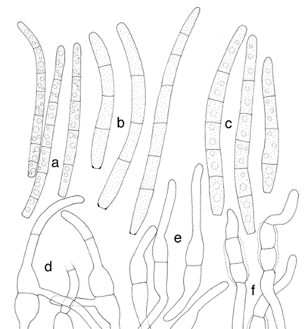
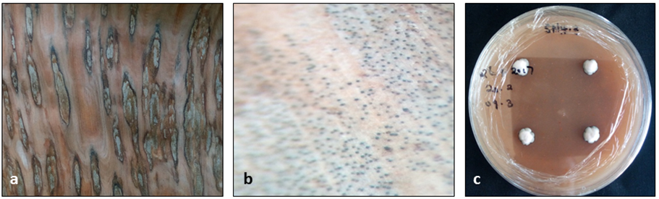
Figure 13. Top: Conidia of Pseudocercospora eumusae (a), P. fijiensis (b) and P. musae (c) (Adapted from Arzanlou et al., 2008). Bottom: Necrotic lesions ideal for ascospore discharge (a), mature pseudothecia observed under a dissecting microscope (b) and single-spore cultures growing on V8 media (c).
Pathogen identification

A preliminary diagnosis of the Pseudocercospora spp. responsible for Sigatoka diseases can be made based on lesion appearance. Sections of banana leaves showing disease symptoms are then inspected for conidia to make a morphological identification. In the absence of conidia, ascospores may be used to produce conidia in culture. If a positive diagnosis cannot be made using symptomology and conidial morphology, molecular diagnosis using gel-based PCR and species-specific primers is carried out (will not be described in the field guide).

Visual diagnosis of disease
It is difficult to identify and distinguish black from yellow Sigatoka based on symptoms alone. The development and appearance of Sigatoka disease symptoms can differ due to various biotic and abiotic factors. These include prevailing weather conditions, nutritional state of the plant and inoculum levels present. Symptom expression may also depend on resistance of the banana variety, and whether such resistance is quantitative or qualitative. A preliminary diagnosis can sometimes be made based on leaf spot symptoms, but to be confident, further observation of fungal structures under a microscope is necessary.

Microscopic diagnosis of disease
Variable symptom expression confounds efforts to distinguish between Sigatoka pathogens, necessitating the use of a microscope to study their fruiting structures. Sigatoka pathogens are morphologically alike, but small differences can be observed when microscope slides are prepared from diseased leaf tissue (Table 5). Leaf spots should therefore be scanned using a dissecting microscope, and sporulating fungal structures transferred to a slide for observation under a compound microscope. Pseudocercospora spp. are differentiated based on their conidial and conidiophore morphology (Table 5).

Direct observation on diseased leaf tissue
Leaf tissue with visible Sigatoka lesions can be cleared, and the fungal structures observed in situ. To induce sporulation, diseased leaf samples (Stage 4 lesions) can be placed in a humid chamber (or seal inside a plastic bag containing sterile filter papers or paper towels soaked in sterile distilled water) overnight at 100% relative humidity at around 25ºC. The high humidity will ensure a profusion of conidia and conidiophores that can be used to identify and differentiate Sigatoka pathogens.

Note: Conidia are present much earlier in P. fijiensis infections and can be observed as early as Stage 2 lesions, while P. musicola conidia can only be seen from Stage 4 lesions.
Procedure
- Cut pieces of leaf tissue containing Stages 2-4 lesions of approximately 1 cm in length and 2 mm in width (Fig. 14).
- Using a dissecting microscope, scan lesions (both top and bottom) for fungal structures. For P. fijiensis, the adaxial part will contain fungal structures, and for P. musicola and P. eumusae, they will be present on the upper surface. If fungal structures are observed these can be picked off the leaf surface and placed in a droplet of cotton blue staining solution. Microscope preparations should then be observed using a compound microscope.
- Alternatively, leaf tissues can be cleared for better observation of fungal structures. To clear the leaf tissue, place 15 x 15 mm square pieces of leaf tissue into Falcon® tubes containing 10% KOH.
- Leave overnight (minimum) at room temperature, then wash samples five times in sterile distilled water for 10 min each time. For P. fijiensis, place the cleared leaf tissue with the lower surface (underside) facing upwards on a glass microscope slide, while for P. musicola and P. eumusae place the upper side upwards.
- Conidiophores associated with lesions can be directly observed on slides, without staining.
- Observing conidiophores and conidia after staining: Stain cleared tissues for 1 min with a solution of 0.5% cotton blue in a mixture of lactic acid/glycerol at 3v/v; or place a few drops of cotton blue staining solution on the surface of the tissue, then cover with a glass coverslip. Seal with clear nail polish if long term storage is required. Observe conidiophores and conidia under compound microscope.

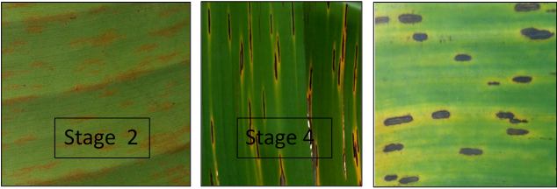
Figure 14. Stage 2 lesion of Pseudocercospora fijiensis (left) and Stage 4 lesions of P. musicola (middle) and P. eumusae (right).

Table 5. Morphological characteristics of the anamorphs Pseudocercospora fijiensis, P. musae and P. eumusae, Sigatoka pathogens of bananas and plantains.
Species | Conidiophores | Conidia
Paracercospora fijiensis | - First appearance at early streak stage according to Fouré’s (1994) Stages 2 to 3  - Mainly on the lower leaf surface  - Emerge singly or in small groups (2 to 6), sporodochia and stromata absent  - Straight or bent geniculate, pale to light brown, 0–5 septate, occasionally branched, slightly thickened spore-scars  - 16.5–62.5 μm × 4–7 μm | - Obclavate to cylindro-obclavate,  - Straight or curved, hyaline to very pale olivaceous, 1–10 septate, distinct basal hilum (scar)  - 30–132 μm × 2.5–5 μm
Pseudocercospora musae | - First appearance at spot stage (Brun’s (1963) Stage 4)  - Abundant on both leaf surfaces  - In dense fascicles (sporodochia) on dark stroma  - Straight, hyaline, mostly without septation and geniculation; no spore scars  - 5–25 μm × 2–5 μm | - Cylindric to obclavato-cylindric, straight or curved, pale to very pale olivaceous, 0–8 septate, no distinct  - Basal hilum  - 10–109 μm × 2–6 μm
Pseudocercospora eumusae | - First appearance at spot stage  - Mainly on the upper leaf surface  - In dense fascicles on brown stroma  - Subcylindrical, hialyne or pale brown below, 0–3 septate, straight to geniculate-sinuous  - 10–25 μm × 3–5 μm | - Subhyaline to pale olivaceous, thick-walled,  - Smooth, subcylindrical, apex  - Obtuse, base subtruncate, straight to variously curved, 3–8 septate  - 30–50 μm × 2.5–3 μm
Adapted from Wardlaw (1972) and Crous and Mourichon (2002).

Molecular Diagnosis of Pseudocercospora species
Molecular diagnosis is used to either confirm morphological results or cases where a positive diagnosis cannot be made using symptomology and conidial morphology. PCR with species-specific primers can be used to unequivocally detect, identify and differentiate Pseudocercospora species. PCR can be conducted on DNA extracted directly from diseased leaf tissues or from pure cultures of the fungus.

Field and greenhouse trials

Field screening of banana plants follows natural field infections. Greenhouse and laboratory screening using a detached leaf assay requires inoculum from pathogen cultures.

Greenhouse screening of banana and plantain genotypes

Starting material
- Banana plants derived from in vitro multiplication (tissue culture or suckers).
- Inoculate 10 wks after start of acclimatisation (plant size 40–60 cm, ~10 leaves).
- For the inoculation technique on leaf pieces, banana plants need to be grown under optimum physiological conditions before sampling.

Inoculum preparation
Inoculations can either be done using mycelial suspension or conidial suspension.

Mycelial suspension
- From an actively growing monosporic culture on PDA, scrap mycelia directly into a sterile mortar with a surgical blade.
- Grind in 5 ml sterile distilled water with a drop of 0.05% Tween 20 into a fine suspension. Filter the suspension through two layers of cheesecloth to get rid of media debris.
- Quantify the suspension using a haemocytometer. Alternatively, harvested mycelia can be weighed on a balance, and fragmented by blending in sterile distilled water. (NB: It is advisable to start with a master suspension, and adjust concentrations as required).

Spore suspension
- Add 3 ml of sterile distilled water with a drop of 0.05% Tween 20 to a sporulating culture (sporulating colonies appear pinkish).
- Dislodge the spores by lightly brushing on the surface of the colony.
- In case mycelial fragments have been dislodged too, sieve the suspension through double layers of cheesecloth.
- Quantify using a haemocytometer under a microscope and adjust to required concentrations using sterile distilled water.
- Prior to inoculation, add 1%v/v Triton X-100 to the inoculum suspension to enable mycelia and spores to adhere to the leaf surface.

Artificial inoculation of banana plants (Abadie et al., 2008)
- Inoculate the youngest leaf using an artist air spray brush (normally used for painting), using a spore suspension of 1 x 10⁵ spores /ml.
- Spray approximately 1 ml of suspension on the lower surface of the youngest leaves using a microsprayer at constant pressure (1.5 kg/cm). Alternatively, use a painters’ brush / camel brush to evenly spread the suspension on the leaf surface.
- For P. fijiensis, inoculate the adaxial part of the leaf, whereas for the other Pseudocercospora spp., inoculate the upper leaf area.
- Allow the inoculated area to dry for 1-2 hrs, and then place plants into a humid chamber with 100% humidity for 48-96 hrs.
- Move the plants into the screenhouse and monitor plants for infection by studying the inoculated leaves for symptoms on a 5-day interval (Fig. 15).

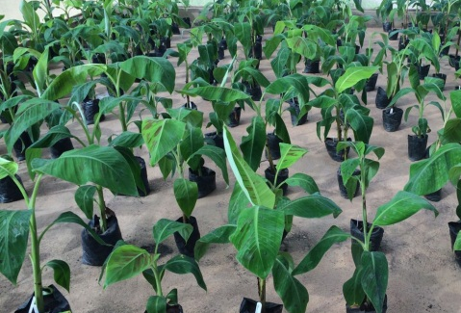
c
b
a
Figure 15: Young macro-propagated plants in a screen house for artificial inoculation (a) and lesion development (b and c) on a susceptible banana genotype (photos b and c from Kumaketch et al., 2015).

Note: Symptoms first appear 10-15 days after incubation. The time from the first to final lesions differs from 20-25 days for a susceptible plant and 60-70 days for a resistant cultivar.

Data to record in greenhouse experiment
- Incubation time: Time between infection with pathogen and appearance of symptoms.
- Leaf area infected (%): Disease severity.
- Symptom evolution time: Time from appearance of first symptoms to development of mature spots.
- Stage of symptoms: Scale 0-6 as described above.
- Latent period: This is the time taken by fungus to start producing mature pseudothecia and ascospores.

Laboratory screening using the detached leaf assay (Abadie et al., 2008)
- Select the youngest fully mature leaf from plants (the second youngest leaf may also be used), cut and transfer to the laboratory. Place the stem in water until required.
- Cut the leaves into large pieces that can easily be cleaned in a 1-l beaker.
- Surface-sterilise leaf pieces in 1% NaHCl solution for 90 s, and wash five to six times with sterile distilled water.
- Aseptically cut leaf pieces into 6 × 6 cm segments, and place them in a Petri dish with the upper leaf surface down on survival medium (0.4% water:agar and 50 mg benzimidazole).
- A 1% technical agar amended with 5 mg/l of gibberellic acid (GA) can also be used. GA at this concentration is able to maintain a green colour in banana leaves for 45-52 days.
- Add a drop of 1% Triton X-100 to the spore suspension prior to inoculation.
- Inoculate using two droplets of inoculum per leaf piece, by pipetting 40 μl of spore suspension (5 × 10⁵ conidial/ml) onto the abaxial side of the leaf.
- Seal Petri dishes with Parafilm and incubate at 25°C with a 12:12 hr light:dark photoperiod.

Caution: It is important to avoid any condensation in the Petri dish to keep leaf pieces alive. Use a climatic chamber with a circular movement of fresh air.
Note: Symptoms first appear 18–20 days after incubation, and the time from the first to final necrosis lesions differs according to the level of host susceptibility from 30 days for susceptible plants to 60–70 days for partially resistant cultivars.

Scoring of Sigatoka trials (Twizeyimana et al., 2007)

Look for symptoms 5 days after inoculation and for up to 32 days. Long periods of assessment are required for genotypes that have higher levels of resistance. Record data on incubation time, disease severity (Table 6), symptom evolution time and symptom stages (see above).

Table 6. Disease assessment key for estimating the infection caused by Pseudocercospora species on a single plant (Disease Severity Index) (Leiva-Mora et al., 2015).
Rating | Description
0 | No visible symptoms of the disease
1 | Less than 1% (only streaks or up to ten spot of the leaf with disease symptoms)
2 | 1 to 5% of the leaf area with symptoms
3 | 6 to 15% of the leaf area with symptoms
4 | 16 to 33% of the leaf area with symptoms
5 | 34 to 50% of the leaf area with symptoms
6 | 51 to 100% of the leaf area with symptoms

Table 7. Proposed field evaluation form for data collection of Sigatoka leaf spot diseases.

DATA COLLECTION TOOL FOR SIGATOKA LEAF SPOTS DISEASES

Date :……………………………………………………..
Farm/farmer ID:…………………………………….…... Country : …………………………………….

District : ……………………………… Village: ….….……………………………….

GPS (LAT.)…………………… (LONG.).……………... Altitude: ……………………………………..
Age of farm (approx.): ……………… Farm size (in acres):………………………….

BANANA FIELD CHARACTERISTICS
Production objective  1=income only  2=food only  3=both | Arrangement of cultivars on farm  1=sole plots for cultivars;  2=random mixtures;  3=In patterns (describe)  4=others (describe) | Presence of agroforestry trees on farm  Yes = 1 (indicate the number of trees on a 50 mat plot);  No= 2 | Arrangement of the trees on farm  1= random  2= at the edges of the farm  3= in relays | Presence of other crops in the banana field | Fields de-suckered?  Yes = 1  No= 2 | Source of planting materials  1=own farm  2=neighbour  3=certified seed | Other agro-ecological practices
 |  |  |  |  |  |  | Organic manure use (indicate type)
 |  |  |  |  |  |  | Mineral fertilizer application
 |  |  |  |  |  |  | Mulching (indicate type and source)

Table 8. Sigatoka leaf spot evaluation sheet.
# | Cultivar name | Growth stage | NSL | YLS | YLSt | NFL | Severity (%)
 |  |  |  |  |  |  | L1 | L2 | L3 | L4 | L5 | L6 | L7 | L8 | L9 | L10 | L11 | L12
1
2
2
3
5

Note:
- Youngest leaf spotted (YLS) will be assessed according to the method of Stover and Dickson (1970), which involves the monitoring of the youngest leaf (from the top of the plant) bearing at least 10 black Sigatoka necrotic lesions. For genotypes lacking a YLS, the plant is assigned a YLS as (NSL+1)
- Youngest leaf with streak symptoms (YLSt) refers to the youngest leaf counting from the top that bears Sigatoka streak symptoms (Early stages). Visually observe every leaf for presence of any Sigatoka symptoms (Stage 1-6) and record the rank of the leaf with symptoms
- Number of functional leaves (NFL) is the total number of leaves with more than 50% leaf green and photosynthetic
- Number of Standing leaves (NSL) is the count of leaves on the plant with an erect petiole. Do not count those leaves with the petiole bent back, other leaves should be recorded regardless of their colour or the colour of their petiole.
- Index of non-spotted leaves (INSL). This is a computed parameter that refers to the proportion of standing leaves without the typical late-stage symptoms of Sigatoka. This index provides an estimation of available photosynthetic leaf area prior to fruit filling and is a measure of Sigatoka resistance in Musa. This parameter is computed as:
$$INSL=\left(YLS-1\right)/NSL×100$$
- Disease severity is recorded as a visual estimation of % leaf area bearing Sigatoka symptoms. This is done per leaf. The disease severity index (DSI) for one plant corresponds to the sum of the scores per leaf calculated as: $DSI=\left\{\sum{nb÷\left(N-1\right)T}\right\}×100$
References and useful reading
Abadie, C., Zapater, M. F., Pignolet, L., Carlier, J. and Mourichon, X. 2008. Artificial inoculation on plants and banana leaf pieces with Mycosphaerella spp., responsible for Sigatoka leaf spot diseases. Fruits 63: 319-323.
Arzanlou, M., Abeln, E.C.A., Kema, G.H.J., Waalwijk, C., Carlier, J., de Vries, I., Guzmán, M. and Crous, P.W. 2007. Molecular diagnostics for the Sigatoka disease complex of banana. Phytopathology 97: 1112-1118.
Arzanlou, M., Groenewald, J.Z., Fullerton, R.A., Abeln, E.C., Carlier, J., Zapater, M.F. and Crous, P.W. 2008. Multiple gene genealogies and phenotypic characters differentiate several novel species of Mycosphaerella and related anamorphs on banana. Persoonia-Molecular Phylogeny and Evolution of Fungi 20: 19-37.
Bennett, R.S. and Arneson, P.A. 2003. Black Sigatoka of bananas and plantains. The Plant Health Instructor. DOI: 10.1094/PHI-I-2003-0905-01
Berendzen, K., Searle, I., Ravenscroft, D., Koncz, C., Batschauer, A., Coupland, G., Somssich, I.E and Ulker, B. 2005. A rapid and versatile combined DNA/RNA extraction protocol and its application to the analysis of a novel DNA marker set polymorphic between Arabidopsis thaliana ecotypes Col-0 and Landsberg erecta. Plant Methods 1: 1- 15.
Brun, J. 1963. Cercosporiosis of Banana in Guinea. A study of the ascospore state of M. musicola. Thesis in the Faculty of Science, University of Paris 35, pp 196.
Carlier, J., Zapater, M.F., Lapeyre, F., Jones, D.R. and Mourichon, X. 2000. Septoria leaf spot of banana: A newly discovered disease caused (anamorph Septoria eumusae) by Mycosphaerella eumusae. Phytopathology 90: 884-890.
Carlier, J., Lebrun, M.H., Zapater, M.F., Dubois, C. and Mourichon, X. 1996. Genetic structure of the global population of banana black leaf streak fungus, Mycosphaerella fijiensis. Molecular Ecology 5: 499-510.
Churchill, A.C. 2011. Mycosphaerella fijiensis, the black leaf streak pathogen of banana: progress towards understanding pathogen biology and detection, disease development, and the challenges of control. Molecular Plant Pathology 12: 307-328.
Conde-Ferráez, L., Grijalva-Arango, R., Raigoza-Flores, N.E. and James-Kay, A.C. 2008. A simple method to obtain single conidium isolates directly from banana (Musa sp.) leaves infected with Mycosphaerella fijiensis Morelet. Revista Mexicana de Fitopatología 26: 76-78.
Crous, P.W. and Mourichon, X. 2002. Mycosphaerella eumusae and its anamorph Pseudocercospora eumusae spp. nov.: Causal agent of eumusae leaf spot disease of banana. Sydowia 54: 35-43.
Dabek, A.J. and Waller, J.M. 1990. Black leaf streak and viral leaf streak: new banana diseases in East Africa. International Journal of Pest Management 36: 157-158.
Fouré, E. 1994. Leaf spot diseases of banana and plantain caused by Mycosphaerella musicola and M. fijiensis. Pages 37-46 in: The improvement and testing of Musa: a Global Partnership (Ed D.R. Jones). INIBAP, Montpellier, France.
Frossard, P. 1980. Appearance of a new and serious leaf disease of bananas and plantains in Gabon: black streak disease, Mycosphaerella fijiensis Morelet. Fruits 35: 519-578.
Fullerton, R.A. and Olsen, T.L. 1995. Pathogenic variability in Mycosphaerella fijiensis Morelet, cause of black Sigatoka in banana and plantain. New Zealand Journal of Crop and Horticultural Science 23: 39-48.
Johanson, A. 1993. Molecular methods for the identification and detection of the Mycosphaerella species that cause Sigatoka leaf spots of banana and plantains. PhD Thesis, University of Reading, England.
Johanson, A. and Jeger, J. 1993. Use of PCR for detection of Mycosphaerella fijiensis and M. musicola, the causal agents of Sigatoka leaf spots in banana and plantain. Mycology Research 97: 670-674.
Kumakech, A., Jørgensen, H.L., Edema, R. and Okori, P. 2015. Efficient screening procedure for black Sigatoka disease of banana. African Crop Science Journal 23: 387-397.
Kung'u, J.N., Seif, A.A. and Waller, J.M. 1992. Black leaf streak and other foliage diseases of bananas in Kenya. International Journal of Pest Management 38: 359-361.
Leach, R. 1946. Banana leaf spot (Mycosphaerella musicola) on the Gros Michel variety in Jamaica: Investigations on the etiology of the disease and the principles of control by spraying. Kingston, Jamaica. Government printer. 118 pp.
Leiva-Mora, M., Alvarado-Capó, Y., Acosta-Suárez, M., Cruz-Martín, M., Roque, B. and Méndez, E.M. 2015. Components of resistance to assess Black Sigatoka response in artificially inoculated Musa genotypes. Revista de Protección Vegetal 301: 60-69.
Lodhi, M.A., Ye, G.N., Weeden, N.F. and Reisch, B. 1994. A simple and efficient method for DNA extraction from grapevine cultivars and Vitis species. Plant Molecular Biology Reporter 12: 6-13.
Mahuku, G.S. 2004. A simple extraction method suitable for PCR-based analysis of plant, fungal, and bacterial DNA. Plant Molecular Biology Reporter 22: 71-81
Meredith, D.S. 1970. Banana Leaf Spot Disease (Sigatoka) caused by Mycosphaerella musicola Leach. Phytopathological Papers 11: 1-47.
Meredith, D.S. and Lawrence, J.S. 1970. Black leaf streak disease of bananas (Mycosphaerella fijiensis): Susceptibility of cultivars. Tropical Agriculture Trinidad 47: 375-387.
Mobambo, K.N., Gauhl, F., Vuylsteke, D., Ortiz, R., Pasberg-Gauhl, C. and Swennen, R. 1993. Yield loss in plantain from black sigatoka leaf spot and field performance of resistant hybrids. Field Crops Research 35: 35-42.
Mortensen, C.N., Collinge, D.B., Jorgensen, H.J.L., Gumisiriya, C., Kumakech, A., Katete, S.N and Okori, P. 2013. Botanicals, endophytes and plant growth-promoting rhizobacteria (PGPR) to control Black Sigatoka disease of banana in Uganda. Technical bulletin.
Ploetz, R. 2000. Black sigatoka. Pesticide Outlook 11: 19-23.
Ploetz, R.C. and Mourichon, X. 1999. First report of black Sigatoka in Florida. Plant Disease 83: 300.
Ploetz, R.C., Channer, A.G., Chizala, C.T., Banda, D.L.N., Makina, D.W. and Braunworth, W.S. 1992. A current appraisal of banana and plantain diseases in Malawi. Tropical Pest Management 38: 36-42.
Sebasigari, K. and Stover, R.H. 1988. Banana diseases and Pests in East Africa. Report of a survey in November 1987. INIBAP, 15 pp.
Stewart, E.L., Liu, Z., Crous, P.W. and Szabo, L.J. 1999. Phylogenetic relationships among some cercosporoid anamorphs of Mycosphaerella-based on rDNA sequence analysis. Mycological Research 11: 1491-1499.
Stover, R.H. 1971. Banana leaf spot caused by Mycosphaerella musicola: contrasting features of sigatoka and black leaf streak control. Plant Disease Reporter 55: 437-439.
Stover, R.H. 1980. Sigatoka leaf spot diseases of bananas and plantains. Plant Disease 64: 750-756.
Stover, R.H. 1983. The effect of temperature on ascospore germ-tube growth of Mycosphaerella musicola and Mycosphaerella fijiensis var. difformis. Fruits 38: 625–628.
Stover, R.H. 1991. Cultural Practices and the leaf spot defoliation complex in Uganda bananas (East Africa AAA). Infomusa 1: 6-8.
Stover, R.H. and Dickson, J.D. 1970. Leaf spot of bananas caused by Mycosphaerella musicola: Methods of measuring spotting prevalence and severity. Tropical Agriculture (Trinidad) 47: 289-302.
Stover, R.H. and Simmonds, N.W. 1987. Bananas. 3rd (ed). Longmans.
Surridge, A.K.J., Viljoen, A., Crous, P.W. and Wehner, F.C. 2003. Identification of the pathogen associated with Sigatoka disease of banana in South Africa. Australian Plant Pathology 32: 27-31.
Tushemereirwe, W.K., Karamura, E.B., Holderness, M., Gold, C.S. and Deadman, M. 2000. Effects of the leaf spot complex and leaf pruning on growth and yield in highland bananas: Results of the first ratoon crop. Acta Horticulturae 540:335-341.
Tushemereirwe, W.K. and Waller, J.M. 1993. Black leaf streak (Mycosphaerella fijiensis) in Uganda. Plant pathology 42: 471-472.
Twizeyimana, M., Ojiambo, P. S., Tenkouano, A., Ikotun, T. and Bandyopadhyay, R. 2007. Rapid screening of Musa species for resistance to black leaf streak using in vitro plantlets in tubes and detached leaves. Plant Disease 91: 308-314.
Wardlaw, C.W. 1972. Banana diseases: Including plantains and abaca. London: Longman, 2nd, 878 pp.
Zandjanakou‐Tachin, M., Vroh‐Bi, I., Ojiambo, P.S., Tenkouano, A., Gumedzoe, Y.M. and Bandyopadhyay, R. 2009. Identification and genetic diversity of Mycosphaerella species on banana and plantain in Nigeria. Plant Pathology 58: 536-546.

The banana weevil

Background

The banana weevil, Cosmopolites sordidus (Germar), is an important pest on bananas and plantains (Musa spp.) (Gold and Messiaen, 2000; Gold et al., 2001). The adult weevil is black and measures 10-15 mm. It is free-living, most commonly found between leaf sheaths, in the soil at the base of the mat and associated with crop residues. The weevil is nocturnally active and very susceptible to desiccation. Adults may remain at the same mat for extended periods of time, while only a small proportion will move >25 m within 6 mo. The weevils are able to but rarely fly. Dissemination is primarily through infested planting material. Many adults live for 1 year, while some survive up to 4 yrs. On moist substrates, the weevil can survive without feeding for several months but will die within a few days in an arid environment. Weevil densities are higher in mulched areas. The sex ratio is 1:1. Oviposition rates of more than 1 egg/day have been recorded, but most commonly oviposition has been estimated at 1 egg/week. The female places its white, oval eggs singly into holes made by the rostrum. Most oviposition is in the leaf sheaths and rhizome surface. Flowered plants and crop residues are favoured stages for oviposition.
The emerging larvae preferentially feed in the rhizome, but will also attack the true stem and, occasionally, the pseudostem. The larvae pass through 5-8 instars. Pupation is in naked cells near the surface of the host plant. Developmental rates are temperature dependent. Under tropical conditions, the egg to adult period is 5-7 wks. Egg development does not occur below 12°C, which may explain why the weevil is rarely encountered more than 1 600 m above sea level. Adult banana weevils are attracted by volatiles emanating from host plants. Cut or damaged rhizomes are especially attractive.

Symptoms

Banana weevil attack has been reported to interfere with root initiation, kill existing roots, limit nutrient uptake, reduce plant vigour, delay flowering and increase susceptibility to other pests and diseases (Fig. 16). Loss of more than 40% of the plant crop due to banana weevil has been recorded. Yield reductions are caused by both plant loss (plant death, rhizome snapping) and lower bunch weights, and have been implicated in reducing banana plantation life. The population of the weevil builds up slowly and damage becomes increasingly important in successive crop cycles/ratoons (Fig. 17).
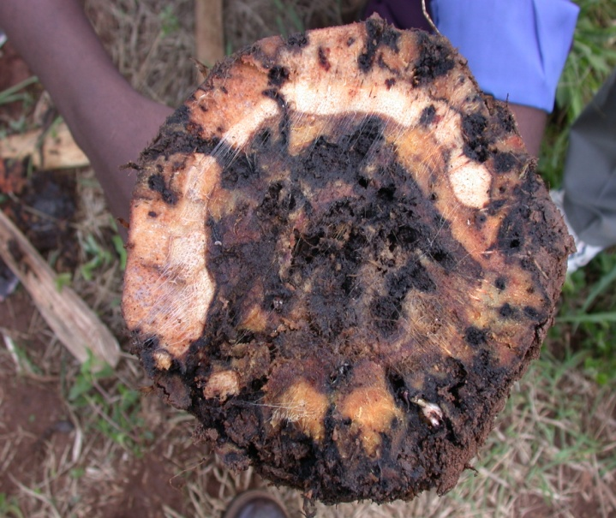
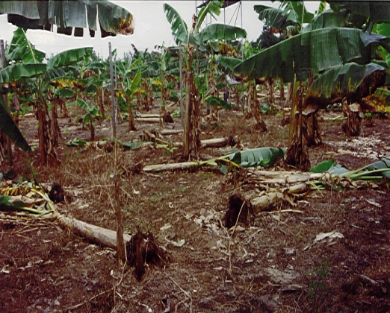
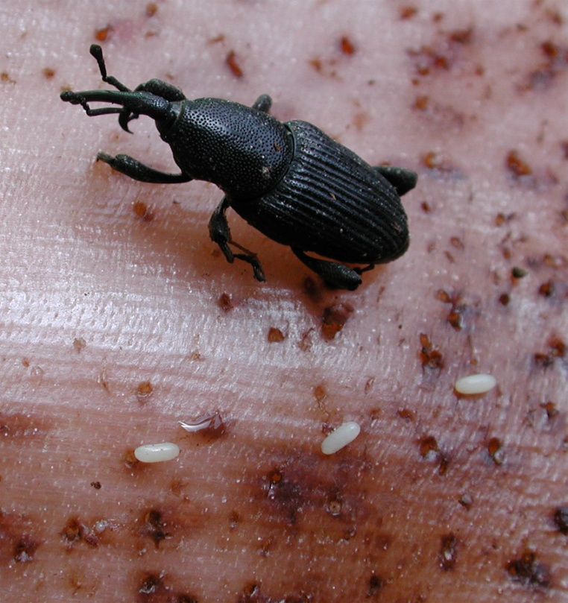
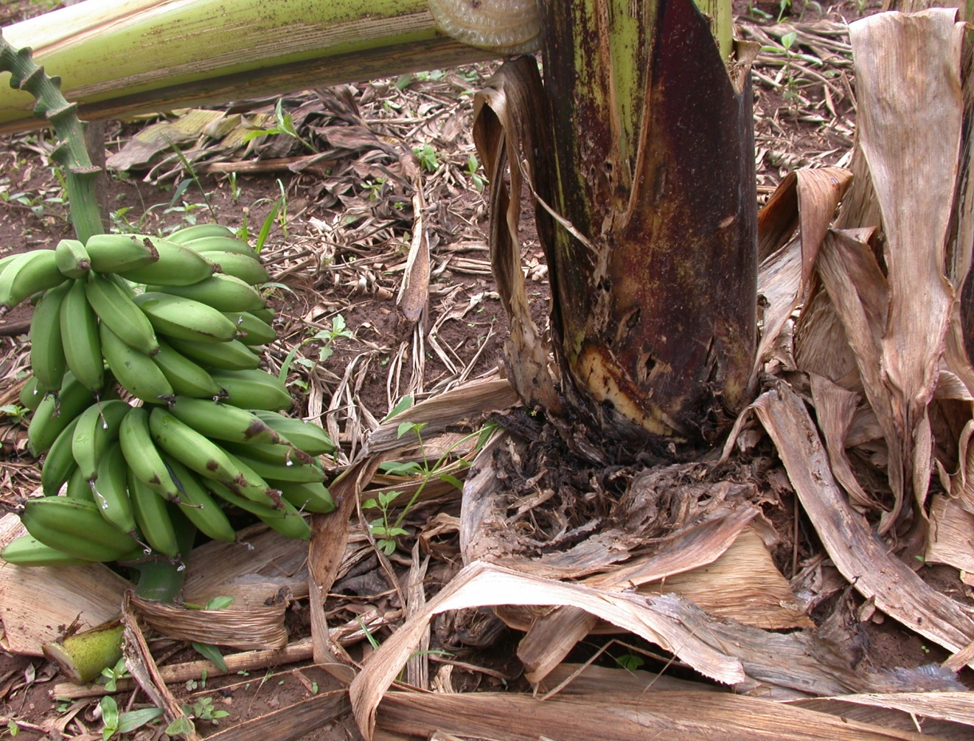
Figure 16. Life cycle and symptoms of banana weevil.
Banana weevil
Oviposition at stembase
Larval tunnels in rhizome
Plant snapping

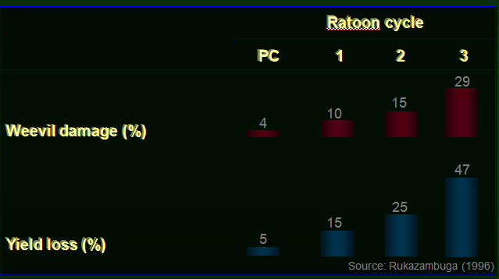
Figure 17. Cumulative weevil damage and yield loss in successive banana cycles.

Sample collection

Setting weevil traps
- Identify a weevil infested banana plantation (usually fields older than 5 yrs).
- Cut the banana pseudostem into pieces of about 30 cm long (usually the lower part of the stem of freshly harvested plants make the best traps) (Fig. 18).
- Split the pseudostem pieces longitudinally into two halves.
- Place the split pseudostems around the mats (preferably on a stump).
- Leave the traps (split pseudostems) for 3 days.
- Collect the trapped weevils in a 30-l bucket.
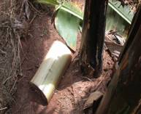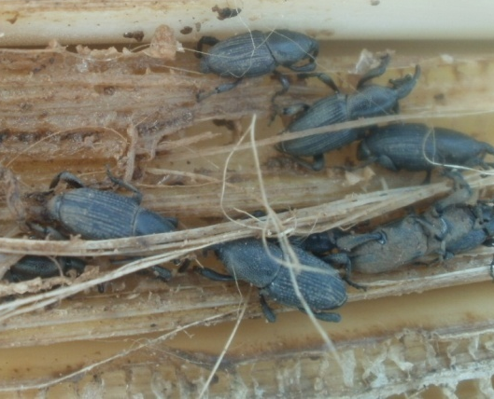
B
A
Figure 18. Split pseudostem trap near the mat (A), Banana weevils trapped after 3 days (B).

Accurate notes must be taken for each sample, including:
- Sample number (one sample number per plant).
- Date of collection.
- Age of plantation.
- Notes about the plantation (Location, village, GPS coordinates, name of dominant banana genotype, main intercrop and the source of the planting material).
- Collectors’ names, and the required phytosanitary certificate/importation permit.
- Other useful observations, such as plantation management practices, chemical control (use of insecticides, note the type), cultural and biological control measures.

Maintenance of healthy cultures of the banana weevils:
- Banana weevil can be cultured on a pared rhizome, preferably of a highly susceptible variety e.g. Atwalira.
- After laying eggs on rhizomes for 5-7 days, rhizomes are transferred to another 30-l bucket.
- Spray rhizomes regularly with water to maintain an appropriate relative humidity of 70-80% using a suitable hand held or hand pump sprayer, until adult weevils emerge (after about 50 days).
- To ensure a regular supply of weevils and of various ages, fresh cultures should be established at monthly intervals.

Banana weevil identification

The adult banana weevil is dark brown to black in colour (Fig. 19), has a long snout and a hard shelled-body.

Sexing banana weevils
- To ensure a continuous production cycle, banana weevils should be infested in a 1:1 (male:female) ratio.
- Use a microscope or hand lens to view punctation on the rostrum to distinguish between male (fully punctated rostrum) and female (less than half rostrum punctated).
- Confirm the sex by checking the last segment of the abdomen, which is curved in male weevils and flat for the females.

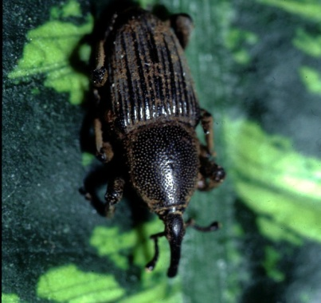
Figure 19. The adult banana weevils.

Field and greenhouse efficacy and screening trials

Resistance in banana against the banana weevil has been attributed to biophysical factors such as rhizome diameter, resin/sap production, rhizome dry matter content, rhizome density/hardness, and suckering ability (number of suckers) (Gold et al., 2001). Generally antibiosis (factors affecting larval performance) rather than antixenosis (attraction) appear to be the most important resistance mechanism in banana. A wide range of damage assessment methods exist and it is critical to know what types of damage best reflects the response of genotypes to banana weevil and how it relates to yield loss. Varieties that should be included during the evaluation of new and improved hybrids for their response to banana weevils are resistant and susceptible checks (Table 9).

Table 9. Reference cultivars for screening for weevil resistance.
Cultivar | Resistant | Susceptible
Yangambi KM 5 (AAA)
Calcutta 4 (AA)
Kibuzi (EA-AAA)
Mbwazirume (EA-AAA)

Artificial infestation of banana weevils in field trials (cultivar screening or yield loss)
- Keep the weevils under dark conditions (room) and then with a red light on for at least 15 hrs prior to release.
- Release/infest 10 banana weevils per plant, 9 mo after planting, in the ratio of 1:1 female to male to create a population density of about 25 000 weevils/ha.
- Determine establishment and multiplication of the weevils 6 mo after releasing by laying traps on mats in at least two blocks and count the number of weevils per trap, where 12 weevils indicates healthy establishment and multiplication.

Scoring of banana weevil trials

Rhizome damage assessment
- Damage assessment requires destructive sampling of rhizomes 0–15 days after harvesting.
- Cut a transverse cross section at the upper rhizome.
- Score weevil damage (tunnels/galleries) as percentage damage on the upper cross-section (at collar area) for both the inner rhizome (central cylinder) and the outer rhizome (cortex).
- Cut another transverse cross section at 10 cm below the collar (lower cross-section).
- Score weevil damage (tunnels/galleries) as percentage damage on the lower cross-section for damage on both the inner (central cylinder) and the outer rhizome (cortex).
- Calculate the total damage as the average of cross section damage of the central cylinder and cortex.

Mat disappearance
- Count the total number of actively growing mats of each genotype in the trial at 6-mo intervals.
- Compare the counts over time to verify the effect of the weevils on stability of the genotypes.
Bioassay for evaluating larval performance on rhizome discs for various cultivars
- The larval stage is the most actively feeding and destructive stage of the banana weevil.
- Weevils are cultured on rhizomes of a susceptible variety (Atwalira) in a 30-l bucket.
- Feed weevils with freshly peeled pseudostem of the susceptible variety; eggs are laid after 2-3 days.
- Collect the eggs from the pseudostem and sterilise them with 20% ethanol (5 ml ethanol in 20 ml distilled water) and 2-3 drops of JIK, on a Petri dish.
- Using a camel hair painters brush spread the eggs on a moistened kitchen tissue in a Petri dish.
- Store at room temperature for about 3-4 days on the Petri dishes, moistening the tissue daily to avoid desiccation.
- Prepare rhizome sections from flowered plants (4 x 2 x 1 cm) for each banana genotype to be screened and place them in Petri dishes.
- Bore the rhizome section with four holes on one side using a small cork borer.
- Place 6-7 day old banana weevil eggs singly in each hole, then cover with rhizome tissue and seal with cling film. Label the Petri dish.
- At 6-7 days, the red coloured heads of the developing weevil larvae are visible in the eggs and close to hatching.
- Using eggs at this stage help to minimise the potential injuries to larvae that can result from handling and transferring them, even using soft camel hair brushes for their transfer.
- This also ensures that only viable eggs are selected for the study.
- Place the Petri dishes in plastic boxes and maintain at room temperature for 8 days, after which the larvae are removed for measurements.
- After 8 days, the larvae are retrieved from the rhizome section and head capsule width, body length, body weight and larval mortality recorded.
- Repeat this procedure three times, which then represent successive replications over time.

References
Gold, C.S. and Messiaen, S. 2000. The banana weevil (Cosmopolites sordidus). Musa fact sheet No.4.
Gold, C.S., Pena, J.E. and Karamura, E.B. 2001. Biology and integrated pest management for the banana weevil Cosmopolites sordidus (Germar) (Coleoptera: curculionidae). Integrated Pest Management Review 6: 79-155.

Useful reading
Gold, C.S. 2000. Biology and integrated pest management of banana weevil, Cosmopolites sordidus (Germar). Pages 28-33 in: Advancing banana and plantain R&D in Asia and the Pacific Vol 10. Eds. Molina, A.B., Roa, V.N., Maghuyop, M.A.G. INIBAP-ASPNET.
Gold, C.S., Rukazambuga, N.D.T.M., Karamura, E.B., Nemeye, P., Night, G. 1999. Recent advances in banana weevil biology, population dynamics and pest status with emphasis on East Africa. Pages 9-22 in: Mobilization of IPM for sustainable banana production in Africa Eds. E.A. Frison, C.S. Gold, E.B. Karamura and R.A. Sikora. Proceedings of a workshop on banana IPM held in Nelspruit, South Africa, 23-28 November 1998. INIBAP, Montpellier, France.
Night, G., Gold, C. and Power, A.G. 2010. Survivorship and development rates of banana weevils reared on excised plant material of different banana cultivars. International Journal of Tropical Insect Science 30: 77–83.
Rukazambuga, N.D.T.M., Gold, C.S., Gowen, S.R. 1998. Yield loss in east African highland bananas (Musa spp., AAA-EA group) caused by the banana weevil, Cosmopolites sordidus Germar. Crop Protection 17: 581-589.

Banana nematodes

Background

Plant-parasitic nematodes are a diverse group of microscopic, worm-like animals that reduce agricultural production by approximately 11% globally, which accounts to millions of tonnes each year. They are found in virtually every environment, both as parasites and as free-living organisms. The amount of damage nematodes cause depends on a wide range of factors such as their population density, the virulence of the species or strain, and the resistance (ability of the plant to reduce the population of the nematode) or tolerance (ability of the plant to yield despite nematode attack) of the host plant. Other factors also contribute to varying degrees, including climate, water availability, soil conditions, soil fertility, and the presence of other pests and diseases. Plant parasitic nematodes of banana can cause significant damage, and are found widespread across banana and plantain-growing areas (Gowen et al., 2005). Given that nematodes are difficult or impossible to see in the field, and their symptoms on crops are often non-specific, the damage that they inflict is often attributed to other, more visible causes (Fig. 20).
Although a relatively large number of species may occur on banana, just a few key species are of importance. Radopholus similis (burrowing nematode) is generally viewed as the most damaging species across banana-growing regions, but nematode spp. of economic importance in East and Central Africa include R. similis, Pratylenchus coffeae and P. goodeyi (root lesion nematodes), Helicotylenchus multicinctus (spiral nematodes) and Meloidogyne spp. (root knot nematodes). Rotylenchulus reniformis (reniform nematode) and Hoplolaimus pararobustus are reported to occur locally in patches. A combination of nematode spp. will most likely be encountered on banana in any given situation. The damage caused by each individual species, therefore, may be difficult to establish.

Symptoms

Pratylenchus spp., R. similis and H. multicinctus infection of roots result in necrotic lesions parallel to the root axis, which eventually decompose and kill the root (Fig. 21). Pratylenchus spp. and R. similis damage will often extend to the central stele, while H. multicinctus tends to remain on the outer edges of the root cortex. As the nematodes often occur together, their damage is combined. Migration of the nematodes through the cortical cells results in the extensive necrosis and visible lesions when roots are sliced. Heavily infected plants are stunted with many dead roots; root surfaces may be cracked or have irregular root swelling.

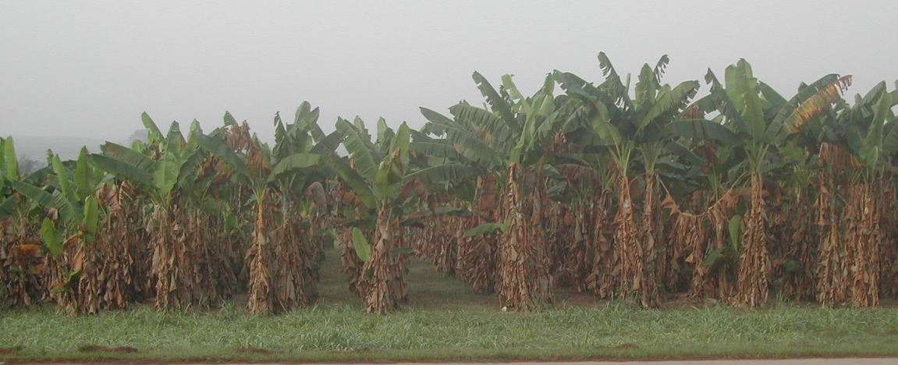
Figure 20. Stunting/reduced height of plantain (plants on left) caused by Pratylenchus coffeae.

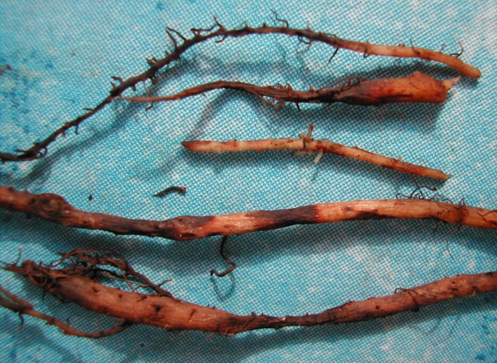
Figure 21. Banana roots showing extended root lesioning (necrosis) caused by Radopholus similis.

Roots infected with Meloidogyne spp. will often have disfigured swollen roots, which also become necrotic and decompose into blackened dead roots (Fig. 22). Above-ground symptoms resulting from root dysfunction and reduced water and nutrient uptake typically translate into reduced growth (e.g. Fig. 20), stunted and chlorotic plants. Affected plants will also have a reduced canopy leaf cover, thinner stems, and will take longer to fruit and yield smaller bunches. Heavily infected root systems become unable to provide plant anchorage and characteristic toppling over of banana plants is typical of nematode damage (Fig. 23).

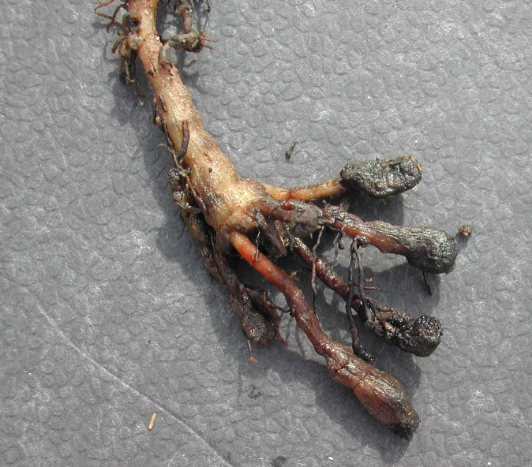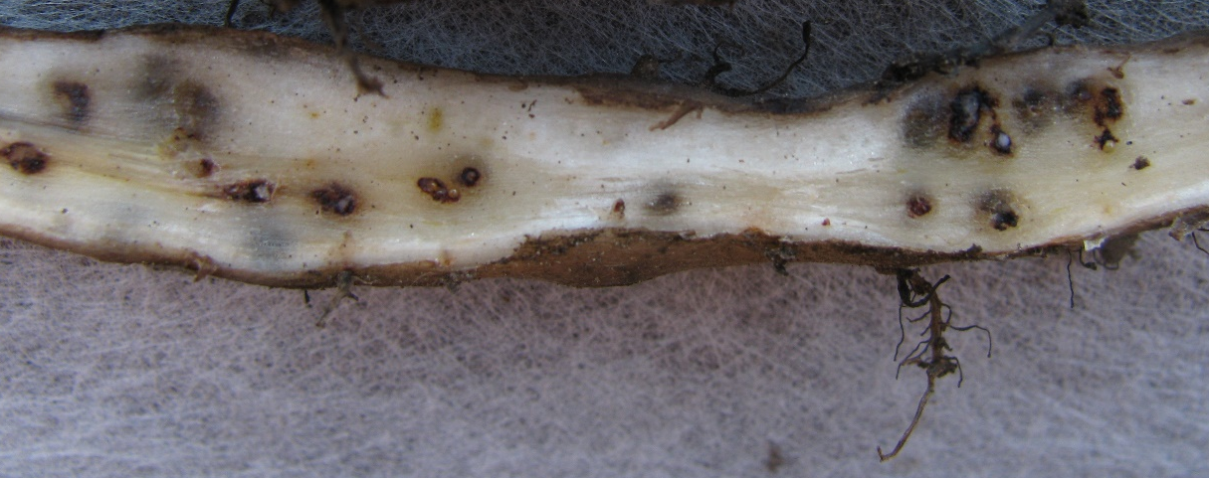
Figure 22. Banana roots infected with Meloidogyne spp. showing irregular root disfigurement and swollen roots, which are necrotic and blackened in places; females surrounded by necrotic tissue (halo’s) observable in split root.

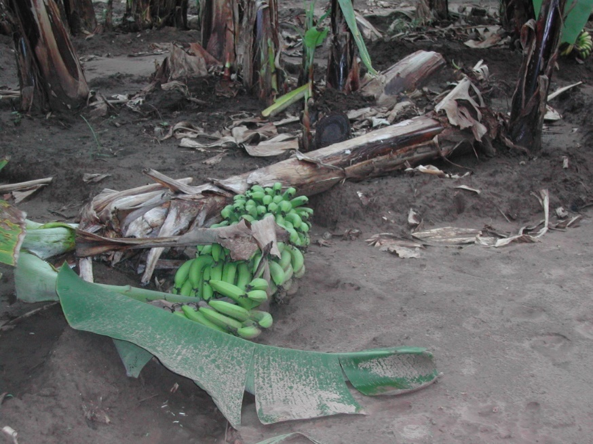
Figure 23. Toppling of banana caused by plant parasitic nematode damage to the root system.

Disease cycle and epidemiology

Radopholus similis nematodes infect at or near the root tip and reside almost exclusively in the root cortex, destroying cells as they migrate through the tissue, feeding as they move along the root. Although rare, they are also known to damage the banana stele. The nematode remains within the root until overcrowding and root decay causes them to migrate. Population development is host-dependent. Males, which do not feed, may comprise 0-50% of the population. In banana, females begin to lay eggs at an interval rate of nearly five per day at optimum temperature. Juveniles may hatch in 2-3 days. Most populations of R. similis reproduce best at intermediate (25ºC) or high (30ºC) rather than lower (15–20ºC) temperatures. Radopholus similis is highly polyphagous, attacking over 250 plant species.
Pratylenchus goodeyi and P. coffeae deposit eggs at rates up to two per day, mainly in root tissue but also in soil along the root surface. All life stages of lesion nematodes can be isolated from both soil and roots. Juveniles sometimes feed ecto-parasitically on plant root hairs, but more commonly are found mostly in the root cortex. Cell death occurs when nematodes migrate through the cell or pause to feed. Life cycles may be completed in 3-4 wks, although at higher altitudes and lower temperatures, life cycles become longer. Both species characteristically have quite a wide host range, especially P. coffeae.
Helicotylenchus multicinctus occurs frequently in roots that are infected with other nematode species. As with the burrowing and lesion nematodes, the spiral nematode enters the root and migrates through the root as it feeds, causing cell damage and death, usually on the outer edges of the root. When extracted, H. multicinctus are distinguished from other nematodes by their longer stylets and by the letter C shaped body when killed. Radopholus similis, Pratylenchus spp. and Meloidogyne spp. are straight when at rest.
On banana, Meloidogyne spp. cause galls and swellings on primary and secondary roots. Sometimes, the root tips are invaded and there is little obvious galling or swelling, but root growth is stopped and new roots proliferate just above the infected area. Infected plants may have a much lower number of secondary and tertiary roots and root hairs. Root knot nematodes are sedentary and, after entering the root, usually just behind the root tip. They establish a feeding site and remain in situ for the duration of their life cycle, which may be as little as 20 days, where areas of necrosis may occur surrounding the white sedentary female (Fig. 22).

Sample collection

Soil samples that represent different banana cropping stages should be collected. Depending on the sampling objectives, the most suitable crop stage to sample is plants at flowering (shooting). During sampling a spade should be used to excavate a ~30 x 30 x 30 cm hole, at ~0.5 m distance from the plant base, from five randomly distributed plants within a farm area/field. Soil and roots from each hole should be collected. The five sub-samples taken from each field can then be mixed homogeneously to constitute a composite sample. Soil clods in each composite sample must be broken up with the fingers, and the soil sieved through a coarse sieve to remove stones and debris. Approximately 500 g of soil must be placed in a clearly labelled plastic bag, sealed and stored in a cool box or under cool/shaded conditions, but out of direct sunlight or heat. Samples have to be transported to the laboratory in a cool box and stored at ~10°C until nematode assay. Samples must be processed as soon after collection as possible, within a few days at most.

Nematode isolation

Nematode extraction
The extraction tray method, based on the Baermann funnel technique (See Coyne et al., 2014), is used for nematode isolation. The method (or variations of it) is also referred to as the modified Baermann technique, the pie-pan method, or the Whitehead tray method (Fig. 24).
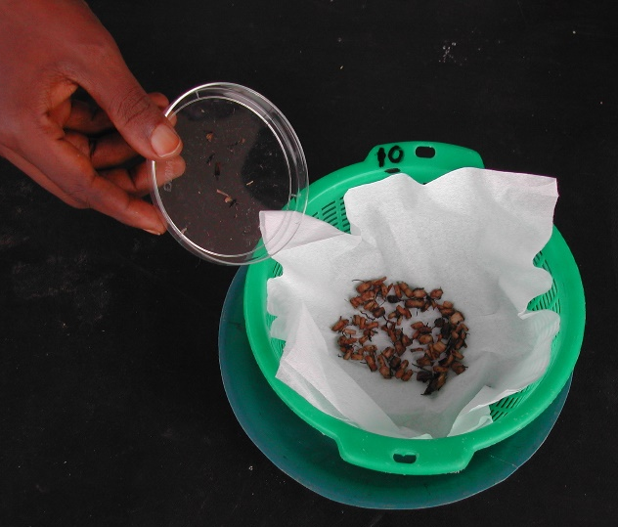
Figure 24. Extraction tray method using a plastic sieve and plate for roots and soil.

Equipment
- A plastic basket (or domestic sieve) made with coarse mesh.
- A plastic dish/tray/plate, slightly larger than the basket.
- Tissue paper.
- Beakers or containers to wash the extraction into.
- Wash bottles.
- Waterproof pen.
- Knife/scissors.
- Weighing scales.
- Large bench space.

Advantages:
- Specialist equipment is not required.
- It is easy to adapt to basic circumstances using locally available materials.
- It extracts a wide variety of mobile nematodes.
- It is a simple technique.

Disadvantages:
- Large and slow moving nematodes are not extracted very well.
- The extractions can sometimes be quite dirty, especially if the clay content of the soil is high, and it can therefore be difficult to count the nematodes.
- The proportion of nematodes extracted can vary with temperature, causing potential variation in results between samples extracted at different times.
- Maximum recovery takes 3–4 days.
Extraction from soil
- Remove roots from sample and place in a separate dish. Label clearly.
- Using a coarse sieve, remove stones and debris from soil and break up soil lumps.
- Thoroughly mix the soil sample in a plastic container (basin, bucket).
- Remove a measure of soil (e.g. 100 ml).
- Place tissue paper (milk filter, paper napkin, etc.), in the plastic sieve/basket that is placed on a plastic plate. Ensure that the base of the sieve is fully covered by the tissue. Label.
- Place the soil measure on the tissue in the sieve. It is important that the soil remains on the tissue paper as spill-over results in dirty extractions.
- Add water to the extraction plates. Take care to gently pour water into the plate (dish) and not onto the tissue paper or soil between the edge of the mesh and the side of the tray.
- Add a set volume to each dish to wet but do not cover the soil or root tissue. Ensure that there is sufficient water for the soil not to dry out. More water is needed for soil samples than root material. Add more later if necessary.
- Leave undisturbed for a set period (48 hr if possible), preferably in the dark, and add more water if it is likely to dry out. Nematodes from the soil or plant tissue will move through the tissue paper into the water below, resting on the tray/plate.
- After the extraction, drain excess water from the sieve and the soil into the extraction.
- Remove the sieve and dispose of plant tissue/soil.
- Pour the water from the plate into a labelled beaker (or cup), using a water bottle to rinse the plate. Leave samples to settle.
- For counting the nematodes in the extraction, reduce the volume of water by gently pouring off or siphoning the excess (taking care not to disturb and lose nematodes and sediment), or by passing the extract through a very small aperture sieve (e.g. 20–30 μm). Wash the nematodes off the small aperture sieve into a beaker for counting, or for reserving if sending away or counting later.

Note: It is very important to ensure good, consistent labelling of all containers used for each sample, as it is very easy to make mistakes. Root and soil extractions should be labelled separately.

Extraction from roots
Roots can sometimes be divided into separate categories, such as larger tough roots and finer feeder roots. It is useful to extract nematodes separately from each category, as the root tissue texture varies and the type of nematodes invading may also vary, as well as densities of the same nematode. Extraction efficiencies may also vary, with the nematodes exiting slower from a larger root.
- Gently tap soil off the roots/tubers or rinse under a tap and then gently dab dry with tissue paper.
- Chop the roots finely with a knife or scissors and place in a labelled dish.
- Mix all chopped root material thoroughly.
- Remove and weigh a sub-sample (e.g. 5 g) of chopped root material using measuring scales.
- Place weighed sub-sample on the tissue paper in the labelled sieve/basket.
OR
- Place weighed root sub-sample in a blender.
- Add small amount of water to cover roots.
- Blend twice for 10 s
- Gently rinse out the blended root mixture onto the tissue paper in the labelled sieve/basket.
- Follow the rest of the procedure for soil extraction above.

The extraction can be collected from trays at 24-hr intervals for 2 days (or more) and combined into one beaker for each sample. All samples from the same study need to be extracted over the same length of time so that all samples are treated in the same way and consistently. The nematode suspension can be reduced by syphoning off the excess and then nematodes counted from the residual amount. Agitate the remaining suspension and remove two or preferably three separate aliquots to count the nematodes, calculating the density from the mean counts. Alternatively, the suspension can be passed through a 38-µm aperture sieve and nematodes collected in a small volume from the sieve for immediate counting, it can be collected in vials / universal bottles for later counting.

Note: It is important to back-wash the sieve, if reducing the volumes through a 38-µm aperture sieve, to ensure that all the nematodes are properly collected.

Killing and fixing nematodes
Concentrate nematodes into a small volume (e.g. 15 ml) in a test tube or universal bottle. Heat a mixture of 2 ml Triethanolamine, 7 ml of a 40% formaldehyde (TAF) and 91 ml distilled water to 99°C, and quickly add an equal volume of the hot TAF to the nematode suspension. This kills and fixes the nematodes in one process.

Nematode identification

Nematodes from each sample can be counted alive or dead and fixed under a dissecting microscope at low magnification (x40), and identified to genus and species.

Pratylenchus
Pratylenchus spp. are stout, with a body length of less than 0.9 mm (Fig. 25). The stylet and lips are highly sclerotized. The lip region is usually not offset from the body, is low and flattened anteriorly, giving the appearance of a flat black cap at the head region. The pharyngeal glands overlap the intestine ventrally. The vulva is posterior and close to the tail and females are monoprodelphic in the interior part of the body. The gubernaculum is simple and does not protrude. Species are most easily differentiated by their tail morphology, with P. goodeyi having a small mucron or ‘blip’ on the tail tip. Otherwise, they are difficult to differentiate.

Photo: N. Luambano
Figure 25. Pratylenchus (worm-like/ vermiform).

Radopholus similis
Female R. similis nematodes are characterised by a slender body that ranges in length from 0.53-0.88 mm (Fig. 26). The head is strongly sclerotised internally, composed of 3-4 annules and not offset. The short, stout stylet has well-developed knobs. The pharyngeal glands overlap the intestine dorsally. The vulva is post-equatorial, both branches of the ovaries are fully developed. The tail terminus is almost pointed and striated. The male head is strongly offset and unsclerotised with a weak stylet that is not used.

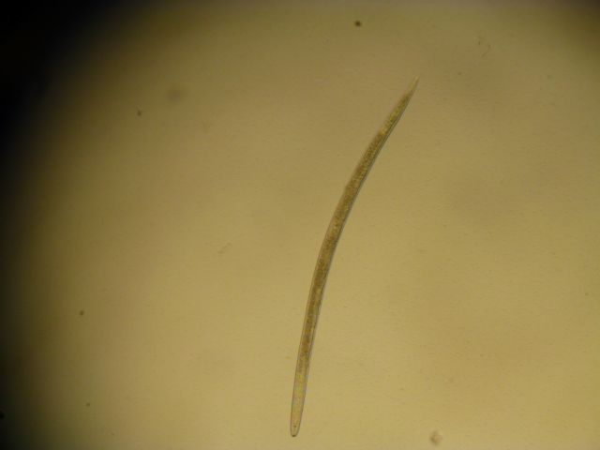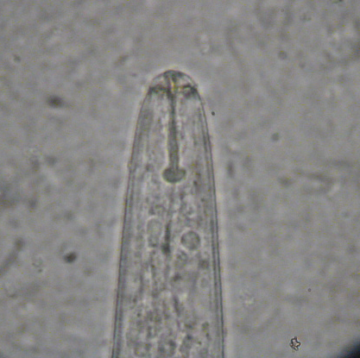
Figure 26. Radopholus similis; full body and head region (Photo: J. Kisaakye)

Helicotylenchus multicinctus
Helicotylenchus multicinctus is best characterised by its C-shaped body when heat-killed. The average life cycle is 30–45 days. An adult female has an oesophagus measuring 22% of its body length and a stylet of 22.5 µm. The lip region is hemispherical, with 3-5 annuli and a heavily sclerotised framework. The stylet is well developed and strong. The tail is slightly tapering, with the anus marked by a slight depression. The vulva is on the ventral side of the body approximately halfway along the body. Males are abundant and shorter and thinner than females (Fig. 27).

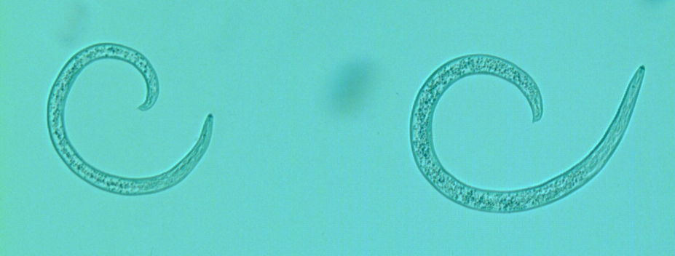
Figure 27. Helicotylenchus multicinctus

Meloidogyne spp.
Juvenile and male Meloidogyne nematodes are mostly collected in soil extractions, as females are sedentary and not mobile, remaining in the root tissue. Newly hatched juveniles have a short, free-living stage which invades the root and establishes the feeding site. The juveniles are not longer than 0.5 mm and have small, poorly developed stylets (Fig. 28). Root-knot nematode males are generally rare and vermiform, and range from 1.1-2.0 mm in length. They have distinct lips and strongly developed stylets. In addition, they often have visible spicules, for mating, and a blunt, rounded tail. The female develops at the feeding site through successive moults, swelling into a spherical shape that feeds from cells around the head region. Each female may produce up to 1 000 eggs in a gelatinous sac. There are numerous species of Meloidogyne, but M. incognita and M. javanica have mostly been associated with banana.

Figure 28. Meloidogyne spp. infective juveniles.
Scoring of nematode trials

Nematode root damage can be evaluated during field sampling of nematodes. The amount of root damage is estimated visually, using a percentage-based scoring procedure (Fig. 29). The damage score usually has a strong relationship with crop yield losses. Scoring nematode damage provides a rapid indication of the damage at that time. However, some judgment may be required when assessing nematode damage. The number of plants assessed can be one or two, up to 25 or more, depending on the area under assessment, objectives and/or field trial layout. Preferably one person, or as few people as possible, should undertake the scoring, for consistency of the scoring. The use of score indicator sheets to regularly compare against is advisable for the same reason.
In order to assess lesion damage, functional roots should be taken from the pooled sample, trimmed to ~10 cm length and sliced longitudinally with a knife. Necrosis, relative to the 100% root surface, should then be assessed on one half of each root. The scores then need to be added together and divided by the number of roots assessed for mean percent necrosis damage for each sample (plot/field). The number of dead and living roots for each sample also needs to be recorded. Field root counts and damage data then have to be collated and analysed to assess nematode damage, and compared with the nematode extraction data.

0% 5%
10% 25%
50% 75%
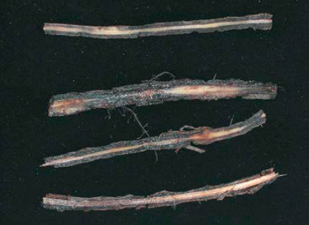
100%
Figure 29. Lesion scoring for nematodes.
References
Coyne, D.L., Nicol, J.M. and Claudius-Cole, B. 2014. Practical plant nematology: a field and laboratory guide. 2nd edition. SP-IPM Secretariat, International Institute of Tropical Agriculture (IITA), Cotonou, Benin.
Gowen, S.C., Quénéhervé, P. and Fogain, R. 2005. Nematode parasites of bananas and plantains. Pages 611-643 in: Luc, M., Sikora R.A. and Bridge, J. (eds). Plant Parasitic Nematodes in Subtropical and Tropical Agriculture. 2nd Edn. CABI Publishing, Wallingford, UK.

Useful reading
Bridge, J. and Page, S.L.J. 1980. Estimation of root-knot nematode infestation levels on roots using a rating chart. Tropical Pest Management 26: 296–298.
Brown, R.H. and Kerry, B.R. 1987. Principles and Practice of Nematode Control in Crops. Academic Press, Sydney. 447 pp.
Hooper, D. J., Hallmann, J. and Subbotin, S.A. 2005. Methods for Extraction, Processing and Detection of Plant and Soil Nematodes. Pages pp 53 – 80 in: Luc, M., Sikora, R.A. and Bridge, J. (eds). Plant Parasitic Nematodes in Subtropical and Tropical Agriculture. 2nd Edn. CABI Publishing, Wallingford, UK.
Hunt, D.J. 2005. Techniques, Morphology and Taxonomy. Gatsby Course on Capacity Building in Nematology in Eastern and Southern Africa. Handout. ILRI, Nairobi, Kenya.
Karssen, G. and Moens, M. (2006). Root-Knot Nematodes. Pages 59-90 in: Perry, R.N. and Moens, M. (eds). Plant Nematology. CABI Publishing, Wallingford, UK.
Luc, M., Bridge, J. and Sikora, R.A. 2005. Reflections on nematology in subtropical and tropical agriculture. Pages xi - xvii in: Luc, M., Sikora, R. A and Bridge, J. (eds). Plant Parasitic Nematodes in Subtropical and Tropical Agriculture. CABI Publishing, Wallingford, UK.
Mai, W.F. and Mullin, P.G. (1996). Plant Parasitic Nematodes. A Pictorial Key to Genera, 5th edition. Comstock, London and Cornell University, Ithaca. 276 pp.

